ECOTwin: A DUAL‑GREENHOUSE VERTICAL FARMING SYSTEM DESIGNED FOR EXPERIMENTAL RESEARCHES

PATRICK ANDRE C. SARANIA

CAPSTONE PROJECT SUBMITTED TO THE FACULTY OF THE
INSTITUTE OF COMPUTING, ENGINEERING, AND
TECHNOLOGY, MALITA, DAVAO OCCIDENTAL
IN PARTIAL FULFILLMENT OF
THE REQUIREMENTS
OF THE DEGREE
OF

BACHELOR OF SCIENCE IN INFORMATION TECHNOLOGY

March 2026

APPROVAL SHEET

This capstone project entitled, “ECOTwin: A DUAL‑GREENHOUSE VERTICAL FARMING SYSTEM DESIGNED FOR EXPERIMENTAL RESEARCHES”, prepared and submitted by Patrick Andre C. Sarania, in partial fulfillment of the requirements for the degree Bachelor of Science in Information Technology, is hereby approved.

DANDY U. DALINA JOHN G. PONTERAS, MS
Panel Member Panel Member

Date Signed Date Signed

JOANNES PAULUS E. JASO, CpE TOWIE L. LAWA, MIT
Adviser Chairman

Date Signed Date Signed

Accepted and approved in partial fulfillment of the requirements for the degree of Bachelor of Science in Information Technology (BSIT).

ENGR. LEO C. RADORES, MSAE
Dean

Institute of Computing, Engineering, and Technology
Southern Philippines Agri-Business and Marine
and Aquatic School of Technology,
Malita, Davao Occidental

__________________
Date signed

TABLE OF CONTENTS

APPROVAL SHEET i
TABLE OF CONTENTS ii
LIST OF FIGURES iii
LIST OF TABLES iv
CHAPTER I 1
INTRODUCTION 1
Project Context 1
Purpose And Description 3
Objectives 5
Project Concept 8
Scope And Delimitation 12
Definition Of Operational Terms 14
CHAPTER II 18
METHODOLOGY 18
Locale 18
Development Method 20
REFERENCES 132

LIST OF FIGURES
Figure 1 Input Process Output of ECOTwin 11
Figure 2 Locale of ECOTwin 19
Figure 3 Development Model of the ECOTwin 22
Figure 4 Use Case Diagram of ECOTwin 25
Figure 5 Activity Diagram of ECOTwin 29
Figure 6 Entity Relationship Diagram of ECOTwin 39
Figure 7 Level 0 DFD Context Diagram of ECOTwin 42
Figure 8 level 1 DFD Context Diagram of ECOTwin 44
Figure 9 Login Interface of ECOTwin 56
Figure 10 Dashboard of ECOTwin 58
Figure 11 Circuit Diagram of ECOTwin 67
Figure 12 Perspective Diagram (Front View) of ECOTwin 69
Figure 13 Perspective Diagram (Side View) of ECOTwin 70
Figure 14 Perspective Diagram (Top View) of ECOTwin 71

LIST OF TABLES

Table I Hardware And Software Requirements 32
Table II Functional Requirements For Software 45
Table III Non-Functional Requirements For Software 52
Table IV Functional Requirements For Hardware 60
Table V Non-Functional Requirements For Hardware 64
Table VI Technical Requirements 74
Table VII Operational Feasibility 78
Table VIII Economic Feasibility (Cost–Benefit And Roi) 81
Table IX Economic Feasibility (Cost Per Unit) 82
Table X Economic Feasibility (Benefit Per Year) 85
Table XI Work Breakdown Structure 88
Table XII Distribution Of Testers 98
Table XIII Unit Test Plan 99
Table XIV Integration Test Plan 108
Table XV Distribution Of Respondents 112
Table XVI ISO/IEC 25010 Project Assessment 113
Table XVII Likert Scale For Hot Fit Acceptability Assessment 117
Table XVIII Operation 121
Table XIV Maintenance Plan 129

CHAPTER I

INTRODUCTION

Project Context
A greenhouse is a protected cultivation structure designed to create a controlled growing environment for crops by regulating temperature, humidity, light exposure, and water availability. By shielding plants from direct environmental disturbances such as excessive heat, heavy rainfall, pests, and sudden weather changes, greenhouses help maintain more stable growing conditions throughout the cultivation period. This makes greenhouse systems useful for crop research, vertical farming, and year-round production because they support more consistent plant growth and improved resource use. In Iraq, the greenhouse context described in the literature emphasizes the need for an active microcontroller-based system to sustain a suitable microclimate for crop production. Reliable and timely forecasting/control of Water Consumption Rate, alongside measurements of temperature, relative humidity, and irrigation time, is presented as a practical way to reduce water loss while maintaining more repeatable conditions for cultivation and study [1]. In Thailand, greenhouse-based vertical farming using natural sunlight shows clear top-to-bottom light gradients, where photosynthetic photon flux density decreases from upper to middle to lower shelf levels. The same study reports that lettuce growth and yields differ across shelf positions, consistent with light being a limiting factor under multi-level shelf arrangements, which supports the need for improved shelf design if experiments are to be made more uniform and comparable [2].
In Metro Manila and other urbanizing areas, manual groundwater measurements occur only once or a few times per year. These infrequent measurements fail to capture rapid changes in extraction rates and contamination levels. As a result, researchers obtain incomplete data that weakens the reliability of scientific findings and water management decisions [3]. Indoor vertical farming setups in Cabuyao, Laguna struggle to maintain precise artificial climate conditions for crops. Key variables such as temperature, humidity, light intensity, and nutrient delivery remain unstable. This inconsistency produces variable growth responses that complicate technology evaluation and scientific trials [4]. In cities like Iloilo City, limited automated monitoring exacerbates these environmental control issues. Harsh local climate conditions further destabilize experimental environments. These regional patterns highlight the urgent need for low-cost, robust sensing and control systems to improve environmental observability in agricultural and water research [5].
Local student and community projects in Buhangin, Malita, Davao Occidental have started simple greenhouse and vertical farming setups to grow leafy greens like romaine lettuce. These projects only observe plants visually without sensors to measure temperature, humidity, light, or moisture, so they cannot accurately compare growth results or understand what factors work best. The proposed system will be tested in this rural Buhangin community, where advanced farm tech is scarce. It provides affordable, locally built sensors and controls designed for tropical Philippine conditions. This makes reliable farming research accessible to schools and small farmers with limited resources.

Purpose and Description
Existing technologies that address controlled-environment agriculture and environmental monitoring generally fall into two practical groups, but both leave gaps for hands-on learning and experimentation in rural school. Internet-connected greenhouse systems can monitor conditions continuously and automate responses, and field testing has shown they can reduce water use while improving greenhouse conditions, but they depend on reliable connectivity, paid cloud services, and higher setup/maintenance complexity [6]. Research prototypes also show that greenhouse performance improves when the growing environment and water delivery are tracked and actively managed, yet these setups still assume access to stable infrastructure and technical support that small institutions may not have [1]. In vertical farming research, even when structures are built successfully, uneven light between shelf levels can produce uneven growth within the same setup, which means design and control limitations can still compromise fair comparisons [3]. On the water-resources side, remote groundwater monitoring systems in the Philippines have been designed to address the reality that extraction is often manually monitored at least once per year, but these efforts focus on measurement and reporting and do not automatically prevent harmful conditions [7].
The proposed “ECOTwin: A Dual‑Greenhouse Vertical Farming System Designed for Experimental Researches” system is designed to bridge these gaps by offering a simple, school-ready platform that supports fair, side-by-side growing trials in one location without relying on constant internet access. It focuses on making growing conditions visible and repeatable for learners; while also enabling basic automatic adjustments so plant responses can be compared more confidently across two matched growing spaces. This approach directly responds to issues seen in controlled-environment farming studies where uneven conditions can distort results, and to monitoring studies where data alone does not address the underlying control problem[3].
This project aligns with SDG 2 because it supports food security and sustainable agriculture by helping communities and schools learn practical methods for improving local crop production and small-scale farming outcomes [8]. It also aligns with SDG 6 because it encourages better water stewardship by promoting careful monitoring and more efficient water use practices in agriculture and related field studies. The primary beneficiaries are rural students, educators, and small-scale growers who need an affordable way to test what works locally, using an approach that can strengthen skills, improve decision-making, and support community-relevant research [9].

Objectives
This study aims to design, develop, and evaluate ECOTwin: A Dual-Greenhouse Vertical Farming System Designed for Experimental Research to monitor, control, and compare key environmental conditions for romaine lettuce cultivation for students, faculty, and researchers at SPAMAST-IASDC in Buhangin, Malita, Davao Occidental.
- To develop a dual-greenhouse vertical farming hardware system that:
- constructs two compact greenhouse structures with vertically stacked PVC racks for romaine lettuce cultivation;
- integrates Arduino Uno and ESP32-based control units for sensor interfacing, local processing, and LAN-based communication;
- installs sensors for monitoring light intensity, air temperature, relative humidity, pH, EC/TDS, water level, and water temperature in each greenhouse;
- integrates relay modules, submersible pumps, exhaust and circulation fans, and stepper-motor-driven shading mechanisms to regulate irrigation, ventilation, and solar exposure;
- provides a PCB-based hardware integration platform with regulated power supply support for stable greenhouse operation;
- integrates wireless and backup communication modules, such as nRF24L01 and GSM/SIM800L, for data transmission and critical alert notification; and
- configures the two greenhouse chambers with distinct environmental treatment conditions for side-by-side comparison of romaine lettuce growth.
- To develop a LAN-based monitoring and control software system that:

  - provides an administrative control module for managing user accounts, greenhouse settings, experiment settings, sensor calibration, and system parameters;
  - authenticates users through username and password verification before granting access to system functions and greenhouse data;
  - accurately displays real-time greenhouse environmental parameters, including sensor readings, actuator states, and experiment conditions;
  - correctly records and updates sensor data from both greenhouse chambers;
  - creates, configures, and tracks greenhouse experiments for comparative studies;
  - automatically evaluates sensor readings against configured thresholds and triggers actuators to maintain target environmental conditions;
  - provides appropriate alerts and notifications when abnormal greenhouse conditions, actuator failures, or system anomalies occur; and
  - generates summary reports, comparison charts, and exportable CSV or Excel files for documentation and analysis.
- To implement system reliability and connectivity through:

  - stable hardware and software operation with minimal unexpected failures or downtime;
  - accurate data recording, consistent actuator response, and continuous local data logging;
  - stable communication between the greenhouse hardware and the web-based application;
  - reliable transmission of sensor data from both greenhouses to the monitoring dashboard without unnecessary delay;
  - secure wiring connections, stable microcontroller operation, and properly calibrated sensors for long-term use; and
  - proper insulation, grounding, fusing, relay isolation, automatic safety shutdowns, and manual emergency override mechanisms.
- To implement system usability and user interface quality through:

  - a clear, organized, and responsive web-based dashboard for monitoring greenhouse data;
  - convenient monitoring and management of greenhouse conditions through the web-based interface;
  - easy-to-learn system functions suitable for students, faculty, and researchers; and
  - scalable and maintainable software that can accommodate additional sensors, actuators, greenhouse units, and future experiments without major redesign.
- To assess the system’s readiness and acceptability through:
  - unit testing;
  - integration testing;
  - functionality testing;
  - reliability testing;
  - connectivity testing;
  - usability testing; and
  - acceptability testing using an ISO/IEC 25010-based project assessment instrument in terms of functionality, reliability, usability, connectivity, and user interface quality.
- To create a patent draft for the:
  - hardware design of the ECOTwin dual-greenhouse vertical farming system; and
  - software architecture of the ECOTwin LAN-based monitoring, control, data logging, alert, and reporting system.

Project Concept
Input-Process-Output (IPO) Framework: This project transforms raw environmental measurements through Arduino-based sensor processing and automated control logic into actionable growth data, system logs, and optimized lettuce cultivation outcomes [10]. This project is a sensor-integrated vertical farming system that provides continuous environmental monitoring and automated control for romaine lettuce cultivation using locally-accessible components, Arduino-based automation, and local network connectivity. The system enables students and researchers in rural educational settings to conduct controlled experiments comparing lettuce growth across different managed environmental conditions, building capacity in sensor technology and data-driven agriculture while generating evidence for optimizing crop production in tropical climates. The IPO framework is suitable for this study because it clearly presents the system’s flow from input, to process, to output, which matches the actual operation of the proposed vertical farming system and helps explain how the technology supports experimental research and greenhouse management .
Fig. 1 presents the overall design of this system, which follows an Input–Process–Output (IPO) concept similar to the structured diagrams used in prior capstone projects, where system inputs, transformation processes, and resulting outputs are clearly identified to guide development, testing, and evaluation. The IPO diagram illustrates how environmental and user inputs flow through embedded hardware-software processes to produce both physical and informational outputs that support romaine lettuce research and instruction at IASDC [3].
In the IPO figure, the Input block includes hardware components such as the dual greenhouse structures, vertical PVC racks, sensors, actuators, and cultivation resources such as romaine seedlings and nutrient solutions, which are to be provided and prepared by the researcher or student, together with user-defined environmental setpoints configured by IASDC faculty and students. The Process block represents the actual sequence of system operations, beginning with sensor data acquisition from temperature, humidity, light, pH, EC/TDS, and water level sensors, followed by Arduino-based signal processing, threshold comparison, wireless transmission through ESP32 or nRF24L01 modules, storage in the phpMyAdmin/MySQL database, and execution of control logic that determines whether actuators such as fans, pumps, lights, and shading mechanisms should be activated to maintain treatment-specific conditions. This process allows the system to continuously monitor both greenhouses in parallel, compare their environmental states, and maintain the desired experimental conditions in a way that supports accurate testing, verification, and validation. Finally, the Output block covers the operational dual-greenhouse facility, real-time and historical dashboards available through a web application, and analyzed growth data that summarize romaine lettuce performance under different environmental treatments for use in classes, research reports, and extension activities [7].
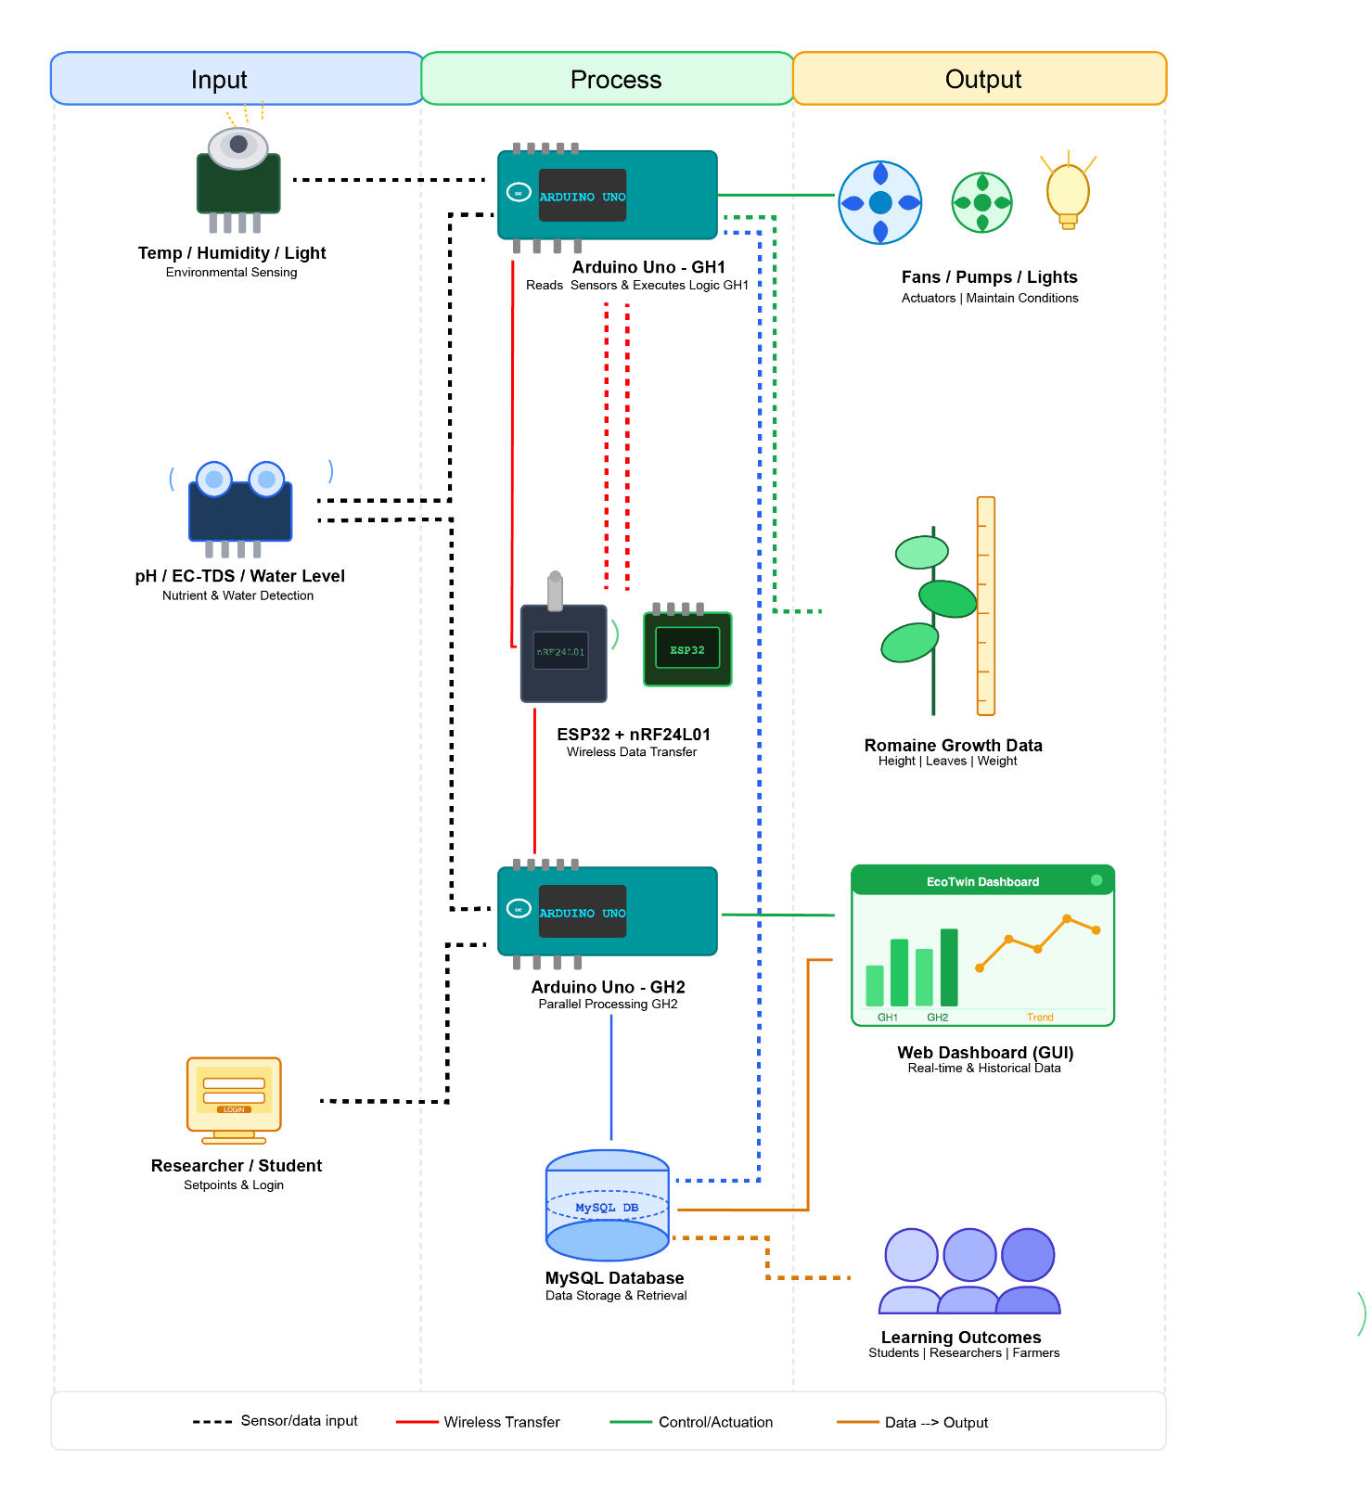
The IPO diagram specifically emphasizes how the dual-greenhouse design enables parallel experiments by routing sensor data from each greenhouse into distinct yet comparable data streams, allowing IASDC students to observe how variations in humidity, temperature, nutrient concentration, or light exposure affect lettuce growth over time [11]. Moreover, by capturing outputs in the form of growth metrics, environmental trends, and system performance indicators, the framework supports iterative improvement of both cultivation protocols and system configuration, aligning with structured work-breakdown and commissioning approaches recommended in prior system design [12].
Fig. 1. Input Process Output of ECOTwin: A Dual‑Greenhouse Vertical Farming System Designed for Experimental Researches

Scope and Delimitation
This project focuses on the development and deployment of an automated hydroponic greenhouse monitoring and control system for romaine lettuce cultivation in Buhangin, Malita, Davao Occidental. It is intended to support controlled-environment agriculture research, student learning, and small-scale experimental crop production through sensor-based monitoring, automated regulation, and local data access within an institutional setting.
The system is designed to provide continuous monitoring and automated regulation of key environmental and nutrient solution parameters, including light intensity, air temperature, relative humidity, nutrient solution pH, electrical conductivity (EC/TDS), water level, and water temperature. It will be used in two compact greenhouse structures with vertically stacked hydroponic racks to support comparative lettuce growth assessment under different environmental treatments. The system uses an Arduino-based microcontroller and ESP32 Wi-Fi module to control submersible pumps, exhaust fans, circulation fans, relay modules, and adjustable shading nets based on predefined threshold values. It also supports local data logging and monitoring through a local area network (LAN), allowing students and faculty researchers to observe environmental conditions and evaluate lettuce growth performance without requiring internet connectivity. The system will be deployed using an existing personal computer located in the IASDC faculty office; therefore, the researchers are not required to provide or deploy their own laptop or personal computer for system operation.
The primary beneficiaries of the project are third-year Bachelor of Science students enrolled in agricultural science and related programs at SPAMAST, particularly those taking courses in controlled-environment agriculture, horticultural production, agricultural engineering, and research methodologies. The system is also intended for IASDC faculty and staff researchers who conduct studies related to lettuce cultivation, environmental optimization, hydroponic systems, and Arduino-based agricultural automation. Secondary beneficiaries include first- and second-year SPAMAST students who may participate in laboratory observations, data gathering, and class demonstrations. The project is geographically limited to users within SPAMAST and the IASDC facility in Buhangin, Malita, Davao Occidental. It does not primarily serve practicing farmers without formal institutional affiliation, non-institutional community groups, or educational institutions outside the Davao Occidental region.
The system is limited to environmental monitoring, automated climate and nutrient-related control, data logging, and comparative growth assessment for lettuce production in a controlled educational and research setting. It is not intended for commercial leafy green production, large-scale market-oriented cultivation, or full farm management. The system does not include machine-learning-based predictive environmental optimization, integration with external weather forecast services, internet-based cloud platforms, biometric image analysis for automated plant health scoring, pest and disease detection, post-harvest processing, or quality analysis. It also does not automate resource accounting, refund management, cost tracking, or maintenance supervision. Routine maintenance, sensor calibration, and resource management remain the responsibility of designated institutional personnel.
The system operates exclusively through the institutional local area network and does not depend on external internet connectivity. This limits remote access to users connected to the on-campus Wi-Fi or LAN environment. The technological components are limited to Arduino-based microcontroller processing, ESP32 Wi-Fi communication, sensors, relay modules, pumps, fans, and motorized shading nets. The Arduino-based platform uses sequential processing, which limits the number of sensors and actuators that can be handled efficiently in real time to approximately 8–12 parameters without hardware expansion. Light intensity regulation is limited to motorized shading net adjustment and does not include supplemental artificial lighting such as LED grow lights. The system also depends on proper sensor calibration, which is assumed to be conducted monthly. The current system has been validated only for romaine lettuce under Philippine tropical to subtropical climate conditions, and its performance with other crops, lettuce varieties, or climate conditions has not been tested.

Definition of Operational Terms
This section presents the operational definitions of the key terms used throughout the study. These terms are defined based on how they are applied in the development, deployment, and evaluation of the automated hydroponic greenhouse monitoring and control system. The definitions are arranged in alphabetical order to provide readers with a clear understanding of the technical concepts, system components, and agricultural terms relevant to the project.
Automated Control. The Arduino-based process of comparing sensor readings to target values and automatically adjusting fans, pumps, or shades to keep conditions stable. This reduces manual work and ensures consistent environments for fair plant growth comparisons [1].
Controlled-Environment Agriculture (CEA). Farming systems where temperature, humidity, light, CO₂, and nutrients are actively managed inside greenhouses or indoor setups, regardless of outside weather. CEA enables precise experiments by eliminating natural climate variations [13].
Daily Light Integral (DLI). Total usable light plants receive daily, measured in mol m⁻² d⁻¹, combining light intensity and hours of exposure. DLI directly affects lettuce leaf growth and weight gain [14].
Electrical Conductivity (EC). Measure of nutrient strength in water solutions, expressed in mS cm⁻¹, with optimal lettuce range of 1.2-2.0 mS cm⁻¹. EC monitoring prevents under- or over-fertilization [15].
Hydroponic System. Soil-less growing method using nutrient water and support media like rockwool or coir. Hydroponics allows exact control of plant food and water for research trials [16].
Internet of Things (IoT). Network of sensors and controllers sharing data for remote monitoring and automation. IoT enables real-time greenhouse management through phone apps [17].
Lactuca sativa. Lactuca sativa. Scientific name for lettuce (romaine var. longifolia), highly light-sensitive requiring minimum DLI 6.5-9.7 mol m⁻² d⁻¹ for growth; insufficient light causes 50%+ yield loss and stunting in controlled environments [18].
Light Use Efficiency (LUE). Grams of plant dry weight produced per mole of light received (g mol⁻¹). Higher LUE shows better light-to-biomass conversion in vertical setups [19].
Local Area Network (LAN). Campus Wi-Fi connecting sensors, controllers, and phones without internet reliance. LAN ensures operation during connectivity outages [20].
Photosynthetically Active Radiation (PAR). Plant-usable light (400-700 nm) measured as PPFD in μmol m⁻² s⁻¹. PAR levels determine photosynthesis rates and growth speed [21].
Romaine Lettuce. Crisp, upright lettuce variety ideal for vertical farms due to texture, nutrition, and steady market demand [22].
Sensor Calibration. Monthly adjustment of sensors against known standards to ensure accurate readings. Calibration prevents data errors that invalidate experiments [23].
Short Message Service (SMS). Arduino-compatible cellular module (SIM800L) that sends threshold violation alerts via SMS to users' phones when Wi-Fi fails or for critical notifications. Provides reliable backup communication in greenhouse IoT systems using AT commands over UART [24].
Total Dissolved Solids (TDS). Total mineral content in water, measured in ppm,
used alongside EC to track nutrient levels and solution quality. TDS helps detect buildup or depletion needing correction [25].
Vertical Farming. Multi-layer indoor crop growing to maximize yield per floor space. Vertical systems enable side-by-side testing of different conditions [26].

CHAPTER II

METHODOLOGY

Locale
The study will be conducted at the Southern Philippines Agri-Business and Marine and Aquatic School of Technology (SPAMAST) Buhangin Campus in Buhangin, Malita, Davao Occidental. Specifically, the dual-greenhouse system will be deployed at the Institute of Agricultural Sciences and Development Communication (IASDC) to be utilized by the Bachelor of Science in Agriculture (BSA) programs. The “ECOTwin: A Dual‑Greenhouse Vertical Farming System Designed for Experimental Researches” capstone project is proposed for this project locale because programs under IASDC require a controlled environment to support precise plant-growth and production studies, and installing the system at Buhangin Campus is expected to assist faculty and student researchers in conducting more reliable experiments and generating research-based data for instruction and extension activities.
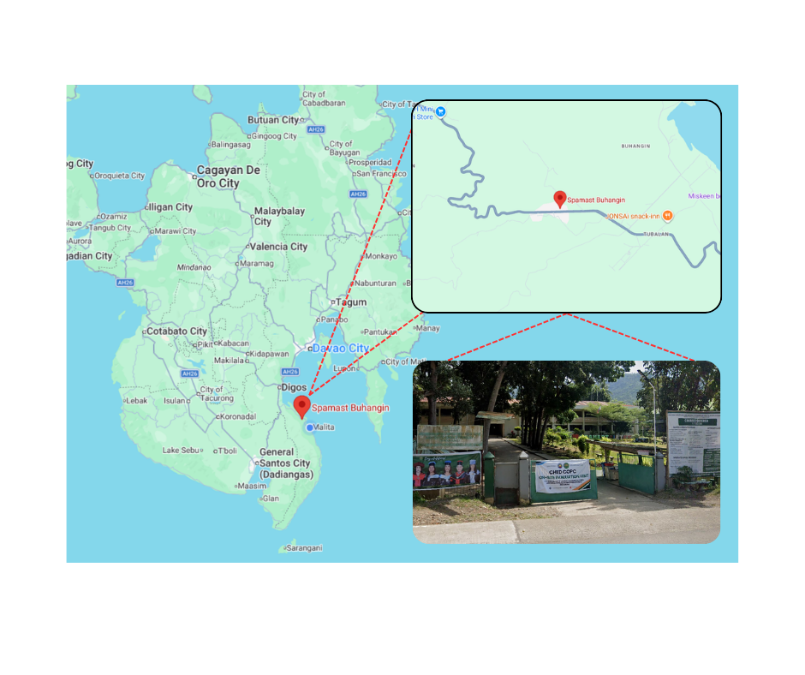
Fig. 2 illustrates the location of the Southern Philippines Agri-Business and Marine and Aquatic School of Technology (SPAMAST) Main Campus, situated in Barangay Poblacion, Malita, Davao Occidental, in the southern part of the Philippines. The project will be deployed within the Institute of Agricultural Sciences and Development Communication (IASDC) facility. In terms of proximity and intended user base, the deployment also supports the SPAMAST Buhangin Campus academic community, approximately 10 faculty members and 48 students who can directly benefit from improved access to a controlled research environment and on-site experimentation support.
Fig. 2. Locale of ECOTwin: A Dual‑Greenhouse Vertical Farming System Designed for Experimental Researches

Development Method
The development methodology provides a structured framework that organizes the project activities from initial planning and requirements definition through design, implementation, testing, and final evaluation. It defines the sequence of development stages followed by the development team, faculty advisers, and institutional stakeholders involved in the dual-greenhouse project [27]. This framework establishes a consistent process for system development and documentation, while outlining procedures for verification and validation during each phase. The methodology also serves as a reference for coordinating development tasks and ensuring that the resulting system addresses the monitoring, control, and data-management requirements identified for student and faculty use [28].
Fig. 3 illustrates the V-Model (Verification and Validation Model) development framework applied to the “ECOTwin: A Dual-Greenhouse Vertical Farming System Designed for Experimental Researches,” showing how each definition phase on the left side of the V corresponds to a matching testing phase on the right side [34]. On the left, the Concept of Operations phase defines how the system is expected to function in the IASDC setting by identifying user roles, greenhouse workflows, experiment procedures, and the dual-greenhouse arrangement for BSABE and BSA students. This is followed by the Requirements and Architecture phase, which translates the project needs into functional and non-functional requirements and organizes them into a structured architecture that connects the greenhouse environment, local processing units, and the web-based interface. The Detailed Design phase then refines these requirements into concrete design outputs such as database structure, data flow, control logic, and component-level behavior, ensuring that every requirement has a direct design basis before implementation begins [27].
On the right side of the V-Model, the corresponding activities focus on Integration, Test, and Verification, System Verification and Validation, and Operation and Maintenance, which ensure that the completed system functions as intended and remains dependable during actual use. After implementation, integration testing confirms that the subsystems for sensing, wireless communication, database storage, web visualization, and actuator control work together correctly, while system verification checks whether the documented requirements are satisfied under controlled test conditions. System validation then involves actual users such as students and faculty who evaluate usability, usefulness, and alignment with research and instructional goals, and the Operation and Maintenance phase provides for calibration, updates, and corrective actions so the system can continue operating reliably across multiple academic terms [29].
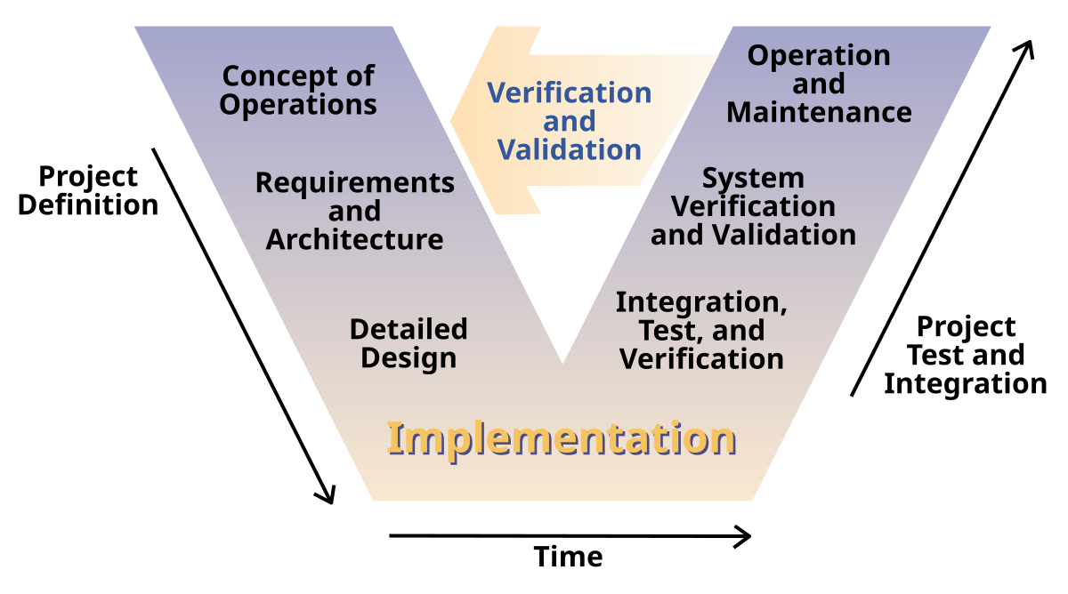
The V-Model is suitable for this study because ECOTwin is a hardware–software system that requires careful planning, traceable requirements, and staged testing before deployment. Since the project includes sensors, microcontrollers, wireless communication, database integration, a web dashboard, and automated actuators, each part must be verified individually and then validated as a complete system to reduce errors and ensure dependable greenhouse operation. This verification-and-validation focus makes the V-Model appropriate for ECOTwin because it directly links every requirement to a corresponding test activity, lowering the risk of missing features or discovering major problems only after implementation [30]. This approach is also consistent with smart greenhouse and IoT agriculture projects, where systematic verification and field validation are necessary to ensure that automated environmental control systems are accurate, robust, and acceptable to users [31].​
Fig. 3. V-Model (HW + SW) of the ECOTwin: A Dual-Greenhouse Vertical Farming System Designed for Experimental Researches
CONCEPT OF OPERATION
The concept of operation provides an overview of how the proposed system performs its core processes through the integration of hardware and software components. It explains the operational workflow from sensor data acquisition and environmental monitoring to automated actuation and data presentation within a controlled local network environment. This section outlines how information flows between embedded devices, environmental sensors, actuators, and the mobile management interface to ensure synchronized performance and reliability. By presenting these interactions, the Concept of Operation establishes a foundational understanding of how the system functions during actual operation [32].
Use Case Diagram
The use case diagram illustrates how users interact with the system by outlining the primary functions and their relationships to corresponding actors, serving as a visual guide to define user roles, actions, and system boundaries and helping developers identify the interactions necessary for both researchers and administrators to perform their tasks efficiently [33].
Fig. 4 illustrates the Use Case Diagram of “ECOTwin: A Dual‑Greenhouse Vertical Farming System Designed for Experimental Researches”, highlighting the interaction between the Researcher/Student and the System Administrator. The Researcher/Student can log in, view real-time sensor data from both greenhouses, monitor environmental conditions, configure environmental setpoints for controlled experiments, receive automated alerts when thresholds are exceeded, and access historical growth data for analysis. Through this process, students and researchers will be able to conduct controlled agricultural experiments efficiently and analyze romaine lettuce growth responses under different environmental treatments during their coursework and research activities. The System Administrator, on the other hand, oversees the overall operation of the system. They are responsible for managing user accounts, calibrating sensors, configuring actuator controls, monitoring system health and performance, and generating data reports or system logs. This interaction between researcher and administrator ensures that the system operates smoothly, promoting experimental validity, data integrity, and educational effectiveness within the dual-greenhouse research framework.
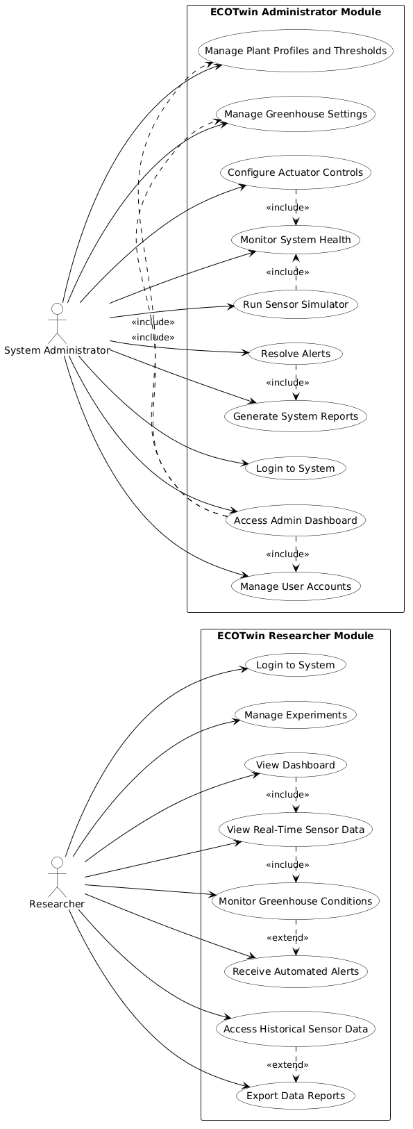
Fig. 4. Use Case Diagram of ECOTwin: A Dual‑Greenhouse Vertical Farming System Designed for Experimental Researches
Activity Diagram
The activity diagram illustrates the workflow of the system by showing how processes progress, branch, and interact among users and system components. It provides a visual representation of system logic that helps organize operations and ensure a clear sequence of tasks. Structured diagrammatic representations improve system reliability and maintainability by presenting an organized view of activities and data flow within the system [34]. The diagram also helps developers and stakeholders understand the system’s dynamic behavior by showing user actions, decision points, parallel processes, and possible execution paths. It serves as a reference for refining processes before implementation and supports communication among team members during system development [35].
Fig. 5 illustrates the activity diagram of the system, showing the process flow for both the Researcher or the Student and the System Administrator. It begins when the user opens the ECOTwin LAN website or mobile application and is presented with the login interface, where credentials must be entered before access is granted. If the login attempt is invalid, the system displays an error message and returns the user to the authentication step; if the credentials are correct, the system creates a session and checks the user role to determine whether the account belongs to a researcher/student or to the administrator.
For the Researcher or Student, the system first loads the dashboard and allows the user to select the greenhouse or experiment module they want to monitor. The researcher can then view the current greenhouse conditions, including real-time sensor readings and environmental trends, and may start or manage an experiment by assigning plant profiles and configuring setpoints. After the experiment begins, the Arduino controller continuously monitors the sensor values, compares them with the preset thresholds, and generates alerts when readings exceed acceptable limits. These alerts help the user identify abnormal conditions early, while the system also stores the alert records and sensor history in the local database. The researcher may continue monitoring the greenhouse, request a report, or export growth data for comparison and analysis, and the session ends when the user logs out.
For the System Administrator, the process begins after successful authentication and role verification, which grants access to the admin dashboard. The administrator can load and manage users, greenhouses, plants, sensors, and system settings, as well as update user accounts, plant profiles, and greenhouse assignments. The admin may also calibrate sensors, run maintenance actions, and validate changes before they are applied to the live monitoring process. When threshold values or plant data are updated, the system saves the changes to the database, logs the activity, and applies the new settings to greenhouse monitoring. The administrator can review system reports, logs, and alerts for troubleshooting and maintenance, and then log out to end the session. The diagram also shows that all actions are connected through the system’s database and control logic, ensuring that data from both greenhouses are recorded consistently and can be used later for verification, reporting, and decision-making. Overall, the activity diagram explains how ECOTwin supports two different user roles while maintaining a continuous cycle of login, monitoring, control, reporting, and maintenance.
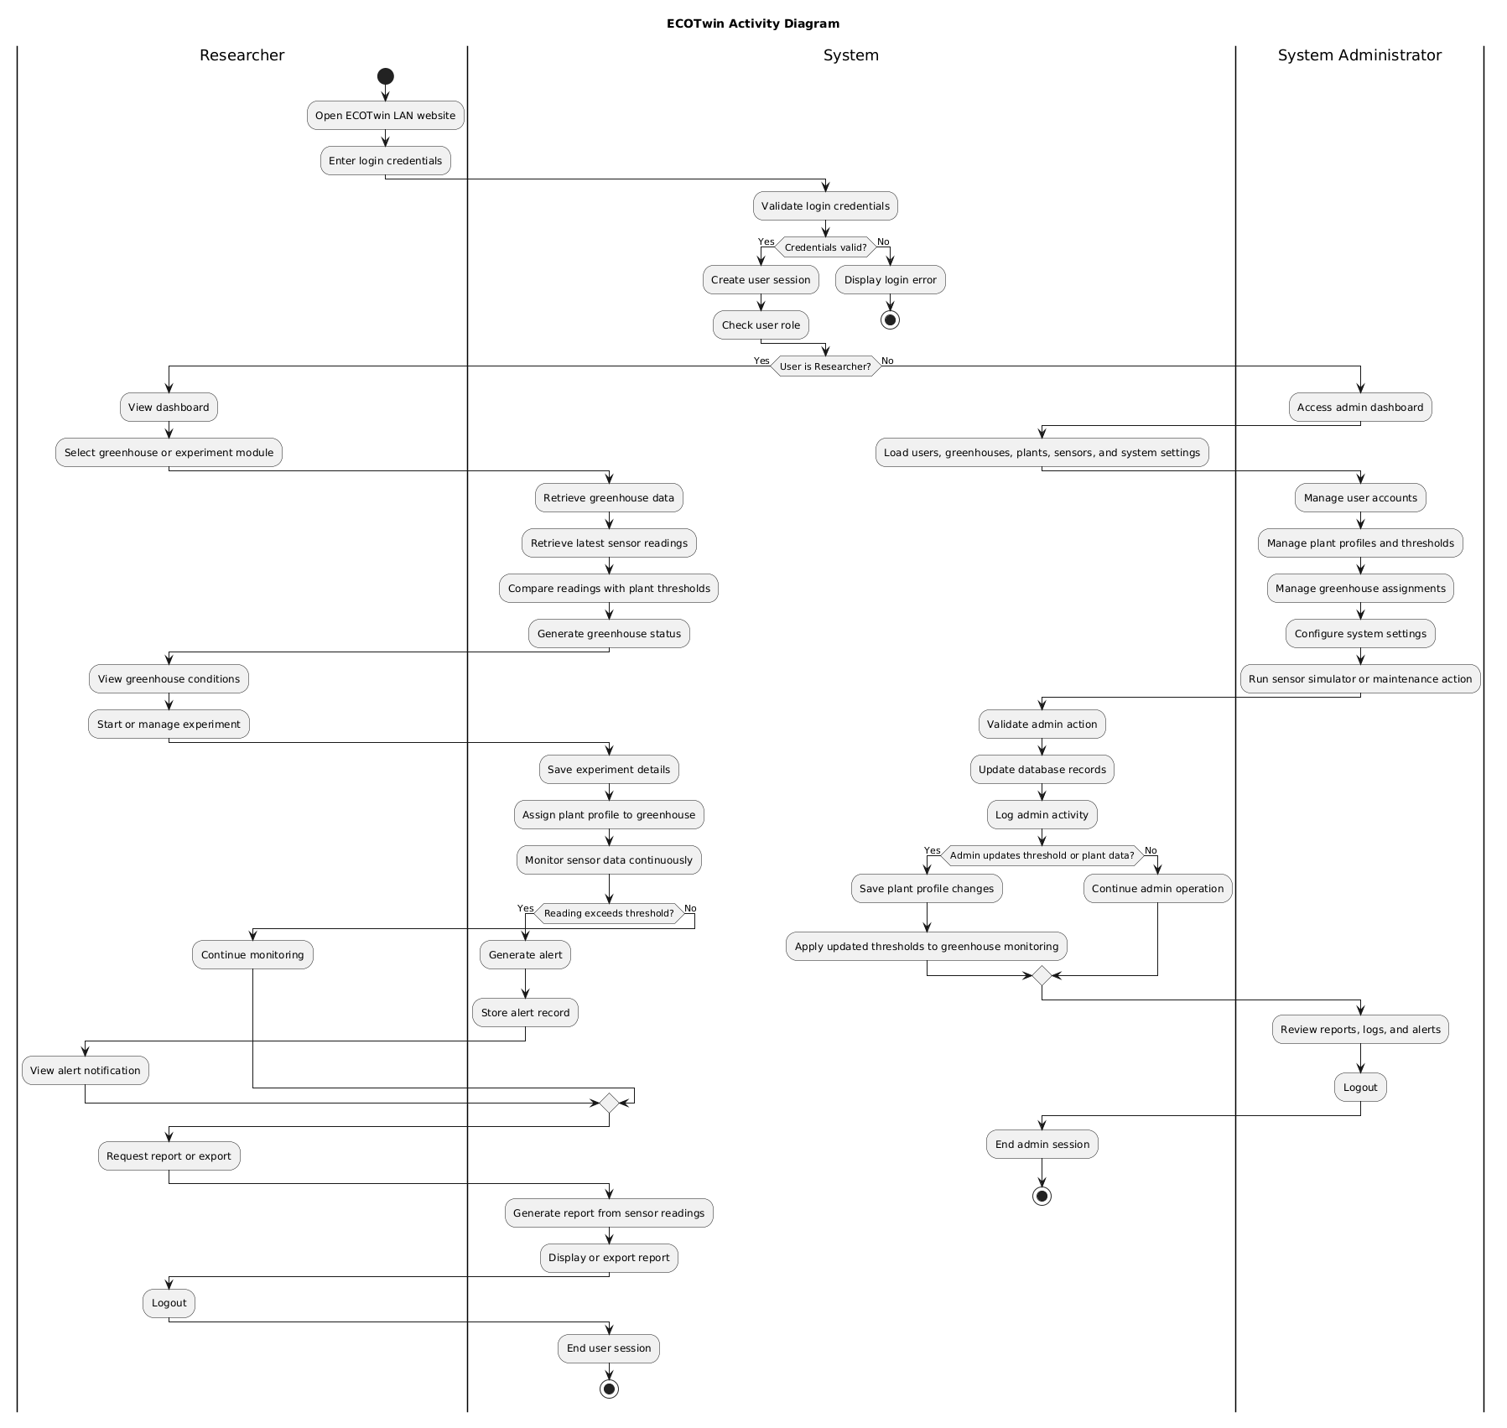
Fig. 5. Activity Diagram of ECOTwin: A Dual‑Greenhouse Vertical Farming System Designed for Experimental Researches
REQUIREMENTS AND ARCHITECTURE
This section defines the functional and non-functional requirements of “ECOTwin: A Dual‑Greenhouse Vertical Farming System Designed for Experimental Researches” and presents the architectural framework that integrates the dual greenhouses, embedded controllers, and web-based monitoring interface within a LAN environment. It identifies what the system must accomplish in terms of continuous environmental monitoring, automated actuation, and research-oriented data handling, while specifying the quality attributes needed to keep the platform reliable, usable, and suitable for long-term experimental use in an academic setting [36].
The architectural design of the system adopts a layered structure similar to IoT-based greenhouse and smart agriculture systems, separating sensing and actuation in the physical layer, local processing and storage in the control layer, and visualization plus user interaction in the application layer. This organization supports clear data flow from sensors to actuators, encapsulates control logic near the greenhouse hardware for resilience during network issues, and allows the website client to remain a lightweight front-end that focuses on visualization and basic configuration rather than heavy computation [37].

Technical Requirements
Technical requirements ensure that this project hardware and software specifications align with stakeholder needs for experimental reliability, affordability, and instructional usability. They support systematic requirement analysis, documentation, and validation so that each selected component and tool remains feasible for procurement, integration, and long-term maintenance within the SPAMAST context [38].
The hardware and software requirements necessary for developing and deploying the “ECOTwin: A Dual-Greenhouse Vertical Farming System Designed for Experimental Research” ensure that all components support reliable monitoring, control, data collection, and system operation for the dual-greenhouse setup. The hardware components, including the Arduino Uno, ESP32, environmental sensors, pumps, fans, relays, GSM module, power supply, and IASDC office personal computer, work together to automate irrigation, climate regulation, nutrient monitoring, wireless communication, alert notification, and local system deployment. The software tools, including Arduino IDE, Visual Studio 2022, PHP, HTML, CSS, JavaScript, MySQL/MariaDB, phpMyAdmin, and XAMPP, provide the environment for firmware development, web application programming, database management, and local server hosting. Together, these hardware and software requirements enable structured data collection, configuration management, system visualization, and experimental monitoring for romaine lettuce growth studies, as shown in Table I.
TABLE I
Hardware And Software Requirements of The ECOTwin: A Dual‑Greenhouse Vertical Farming System Designed for Experimental Researches
Requirement |  | Purpose
Hardware
Arduino Uno | This will be used as the primary microcontroller to read sensor inputs and control actuators for each greenhouse chamber.
Electrical Conductivity / Total Dissolved Solids Sensor | These will be used to measure electrical conductivity or total dissolved solids of the nutrient solution, indicating its concentration for plant growth.
Fans | These will be used to provide ventilation and air circulation inside the greenhouse, helping regulate temperature and humidity.
GSM Module (SIM800L) | This will be used to send SMS alerts directly via AT commands to researchers' phones when critical thresholds are exceeded or system anomalies detected, providing reliable communication redundancy independent of internet connectivity.
Light Sensor (Light Dependent Resistor) | This will be used to detect ambient light intensity in order to characterize lighting conditions affecting lettuce growth.
Microcontroller (ESP32) | This will be used to provide Wi-Fi connectivity, local processing, and communication between the greenhouse controller and the LAN-based data application.
Motor (28BYJ-48 Stepper Motor + ULN2003 Driver) | This will be used to provide precise automated retraction of shading nets based on light intensity (>800 lux) and temperature (>32°C) thresholds, enabling dynamic solar radiation control across the 73cm greenhouse depth with 4096 steps per revolution for exact positioning.
PCB Board | This will be used as the centralized interface integrating Arduino Uno, ESP32, relay modules, and sensors into a single, compact, reliable circuit board with proper power distribution, signal conditioning, and protection circuits for stable greenhouse operation.
pH Sensor Kits | These will be used to monitor the pH level of the nutrient solution and support adjustments to maintain optimal growing conditions.
Power Supply | This will be used to deliver stable power to all components.
Relay Modules | These will be used to switch pumps, fans, and other high-voltage devices safely using low-voltage control signals from the microcontroller.
Submersible Pump | This will be used to circulate or deliver water and nutrient solution to the plants according to the configured schedule or control logic.
Temperature–Humidity Sensor (DHT22) | This will be used to measure air temperature and relative humidity inside each greenhouse to monitor environmental conditions.
Water Level Sensor (Printed Circuit Board-Type) | This will be used to monitor nutrient solution or water level in the reservoir and trigger refilling or alerts when levels are low.
Waterproof Temperature Sensor (DS18B20) | This will be used to measure water or nutrient solution temperature to ensure it remains within the desired range.
Wireless Module (nRF24L01) | This will be used to enable low-power wireless communication between distributed sensor nodes and the main controller when wired connections are impractical.
Software
Arduino IDE |  | This will be used to write, compile, and upload firmware to the Arduino Uno and ESP32 modules.
CSS | This will be used to design and style the ECOTwin web-based monitoring and management interface.
HTML | This will be used to structure the web pages of the ECOTwin monitoring and management system.
JavaScript | This will be used to provide interactive functions, dynamic updates, and client-side communication with the system APIs.
MySQL / MariaDB | This will be used as the database system for storing sensor readings, configuration parameters, user records, alerts, and experiment logs.
PHP | This will be used for server-side processing, database communication, authentication, and system management functions.
Visual Studio 2022 | This will be used to develop the monitoring and management website interface and handle data visualization and configuration tasks.​
XAMPP | This will be used to run the local Apache web server, PHP environment, and MySQL/MariaDB database needed to deploy the ECOTwin system on the IASDC office personal computer.

DETAILED PROJECT DESIGN
The detailed project design for “ECOTwin: A Dual‑Greenhouse Vertical Farming System Designed for Experimental Researches” translates the system’s monitoring and control objectives into a structured web-based architecture that links greenhouse hardware, edge controllers, and a browser-accessible dashboard over the local network. It defines how sensor acquisition, rule-based actuation, data storage, and visualization are partitioned into coordinated modules, following the layered and modular structures commonly adopted in web-based greenhouse and smart farm systems to support reliability and ease of maintenance [39].
Software Design
The software design organizes this project into distinct layers and components, including a backend service that receives data from the ESP32/Arduino nodes, a phpMyAdmin-based persistence layer for time-series records, and a web frontend that renders real-time and historical greenhouse conditions to authenticated users. Responsibilities are divided into modules such as data ingestion APIs, device management, rules and threshold evaluation, and notification services, reflecting best practices in web-based greenhouse and agricultural monitoring applications that emphasize clear separation between data handling, business logic, and presentation for scalability and maintainability [40].

Database Design
The database design specifies how this project structures and relates information such as sensor readings, greenhouse profiles, device configurations, and user accounts in a relational phpMyAdmin schema to support consistent, query-efficient storage of time-series data. Tables for measurements, actuations, thresholds, and experiments are normalized where appropriate, while time-indexed fields receive focused indexing to accelerate range queries in the web dashboard, following recommendations from IoT greenhouse and smart farm studies that use phpMyAdmin to manage large volumes of environmental data and highlight the importance of indexing and partitioning for responsive analytics.
Fig. 6 illustrates the entity–relationship diagram of this project web-based dual-greenhouse research framework, showing how core entities such as Users, Greenhouses, Sensors, Actuators, Readings, Actuation Logs, Experiments, and Thresholds are related to support monitoring, control, and research data management. Each User record stores authentication and role information and can be associated with multiple Experiments, while each Experiment links to one or more Greenhouses where treatments are applied; every Greenhouse then owns multiple Sensors and Actuators that capture environmental parameters or execute control actions inside that structure. The Sensors table identifies each physical sensor and is connected to the Readings table through a one-to-many relationship that stores timestamped measurements, whereas the Actuators table connects to Actuation Logs to record when and why a device was switched on or off; Thresholds associate specific Experiments, Greenhouses, and Sensors with configured minimum and maximum values, allowing the backend to decide when to trigger actuators and ensuring that all operational data remains traceable for romaine lettuce trials.

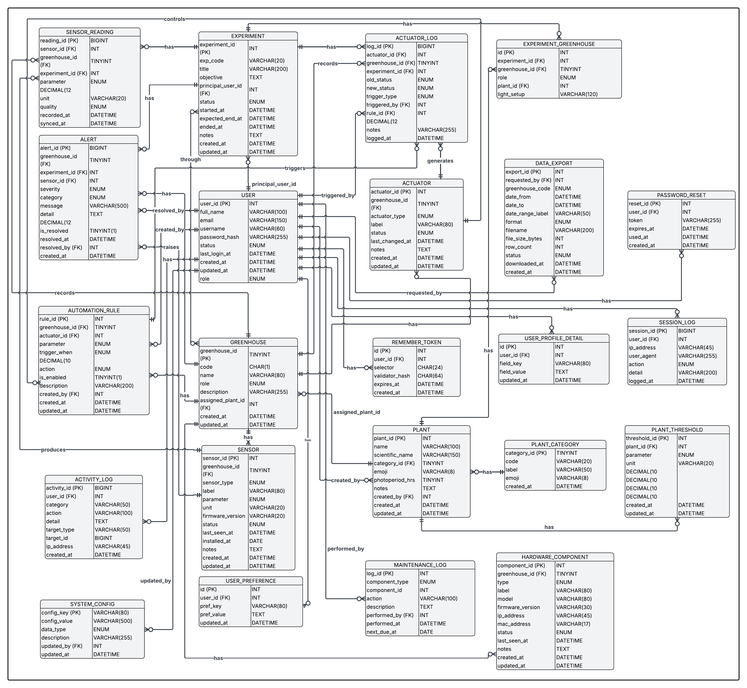
Fig. 6. Entity Relationship Diagram of ECOTwin: A Dual‑Greenhouse Vertical Farming System Designed for Experimental Researches

Data Flow Diagram
The data flow diagram for this project describes how information moves between external users, greenhouse hardware, and the web-based monitoring system, emphasizing structured, traceable flows typical of agricultural IoT applications. Sensor nodes in each greenhouse send periodic readings from the embedded controllers to this system Web Server process, which validates and stores data in the central phpMyAdmin Database while also updating cached values for real-time dashboards, similar to other web-based greenhouse monitoring systems that separate acquisition, processing, and storage stages [39]. Researchers and students, acting as external entities, interact through a browser: they log in, request charts or tables, and optionally configure thresholds or experiment metadata, and the Web Server responds by querying the database and returning processed views, while a separate Control Logic process evaluates incoming readings against Threshold Settings to generate control commands back to the Greenhouse Controller, which then drives actuators such as pumps and fans and logs each actuation event for later analysis [47].
Fig. 7 presents the Level 0 Data Flow Diagram of the ECOTwin Greenhouse Monitoring and Management System. The diagram shows the overall exchange of data between the central Process 0: ECOTwin Web System and its external entities: the ESP32 LAN Gateway, Greenhouse Hardware, System Administrator, and Researcher. At this level, the entire web application is represented as one main process to show the system boundary and the major inputs and outputs.
The ESP32 LAN Gateway provides LAN access and website redirection to the ECOTwin Web System, while the system returns the website URL or gateway configuration. The Greenhouse Hardware sends sensor readings and actuator status to the web system, and in return receives control commands and configuration updates for greenhouse devices. The System Administrator sends login, administrative, and configuration requests, while receiving authentication responses, dashboard data, logs, and alerts. The Researcher sends login credentials, experiment details, observation notes, and report requests, and receives authentication responses, greenhouse status, graphs, alerts, and exported data from the system .
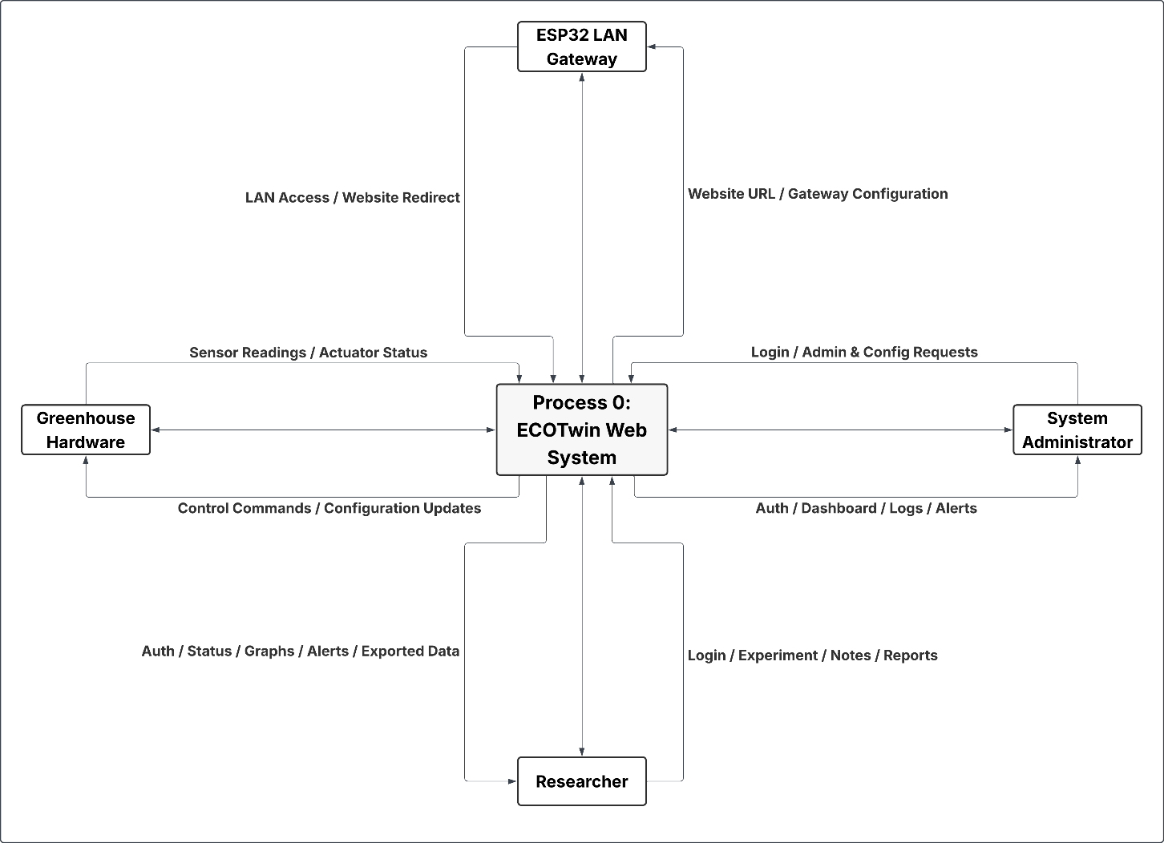
Fig. 8 illustrates the Level 1 Data Flow Diagram of the ECOTwin Greenhouse Monitoring and Management System, decomposing the main web system into seven subprocesses: Authenticate User, Monitor Greenhouse Conditions, Manage Experiments, Manage Plant Profiles and Thresholds, Generate Alerts and Reports, Manage Actuators and Hardware, and Administer System. The diagram shows how the ESP32 LAN Gateway provides LAN access and website responses, while the Researcher and System Administrator submit login credentials that are validated through the user records and recorded in the session and activity logs.
Fig. 7. Level 0 DFD Context Diagram of ECOTwin: A Dual‑Greenhouse Vertical Farming System Designed for Experimental Researches
After authentication, the Monitor Greenhouse Conditions process receives sensor readings and actuator status feedback from the Greenhouse Hardware, stores recorded readings, and provides real-time greenhouse status and dashboard data. The Manage Experiments process handles experiment setup, greenhouse assignments, and experiment records, while Manage Plant Profiles and Thresholds stores plant profiles, threshold values, and threshold updates used for monitoring. The Generate Alerts and Reports process uses sensor readings, experiment data, alert records, and export records to produce alerts, graphs, reports, and exported data for users. The Manage Actuators and Hardware process handles actuator control requests, hardware configuration, simulator readings, and actuator logs, sending control commands back to the greenhouse hardware. Finally, the Administer System process manages user records, system settings, greenhouse management data, audit logs, and maintenance logs, supporting the administrator’s control over the ECOTwin system.
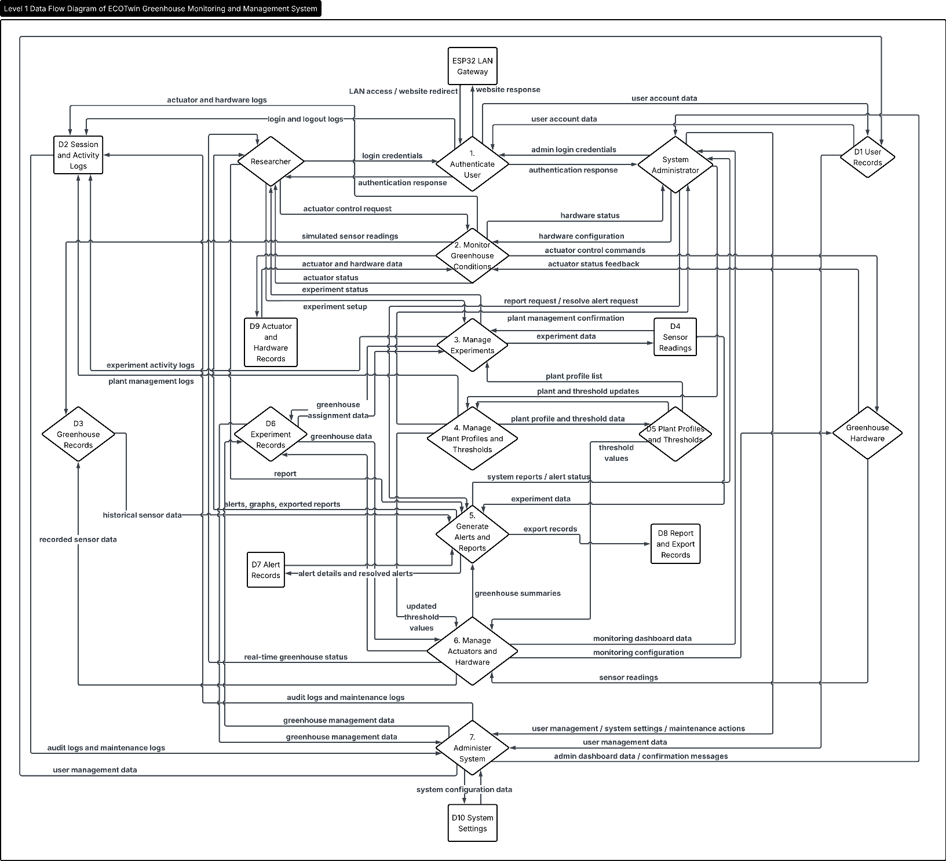
'Functional Requirements
Fig. 8. level 1 DFD Context Diagram of ECOTwin: A Dual‑Greenhouse Vertical Farming System Designed for Experimental Researches
Functional requirements define the specific operations the system must perform to satisfy user and administrative needs. They describe how inputs such as sensor readings, user commands, and configuration parameters are processed to produce outputs including real-time dashboards, automated actuator responses, alerts, and historical reports. In essence, they specify what the system should do and how it responds to events at the system environment boundary, forming the basis for testable behaviors and acceptance criteria [41].
The functional requirements of the system are organized according to its major modules. It identifies the specific operations performed by the system and the user interface provisions that allow administrators and researchers to manage accounts, monitor greenhouse conditions, handle experiments, configure plant thresholds, analyze greenhouse data, generate reports, and maintain system settings, as shown in Table II.
TABLE II
Functional Requirements for Software of the ECOTwin: A Dual‑Greenhouse Vertical Farming System Designed for Experimental Researches
Module | Functional Requirement
Authentication and Account Access | - the system will validate user login credentials before granting access [a]  - the system will verify the correctness of the email and password entered by the user [a]  - the system will lock login attempts temporarily after repeated failed login attempts [a]  - the system will allow users to register an account for administrator approval [b]  - the system will allow users to recover account access through the forgot-password email process [b]  - the system will redirect users based on their role and current experiment status [a]
Dashboard Monitoring | - the system will display a live overview of both greenhouse chambers [b]  - the system will show current sensor readings for environmental parameters [b]  - the system will display recent events and alerts from the greenhouse system [b]  - the system will show hardware and sensor status indicators [b]  - the system will provide visual indicators for normal, warning, and critical greenhouse conditions [b]
Greenhouse Management | - the system will display greenhouse chamber data including readings, thresholds, sensors, actuators, and alerts [b]  - the system will allow authorized users to update automation threshold rules [b]  - the system will allow authorized users to manually toggle actuator states [b]  - the system will retrieve trend data for greenhouse environmental readings [a]  - the system will restrict greenhouse setting changes when an active experiment prevents reassignment [a]
Experiment Management | - the system will allow authorized users to create a new greenhouse experiment [b]  - the system will require experiment details such as title, assigned researcher, description, and schedule [b]  - the system will display the currently active experiment [b]  - the system will allow authorized users to end an active experiment [b]  - the system will keep a history of previous experiments [a]
Plant Library and Threshold Profiles | - the system will display plant profiles with category, scientific name, photoperiod, notes, and threshold values [b]  - the system will allow administrators to add new plant profiles [b]  - the system will allow administrators to edit existing plant profiles and threshold values [b]  - the system will allow administrators to delete plant profiles when they are not assigned to a greenhouse [a]  - the system will filter and search plant profiles by category or keyword [b]
Greenhouse Plant Assignment | - the system will allow administrators to assign a plant profile to Greenhouse A or Greenhouse B [b]  - the system will display the active threshold profile of each assigned greenhouse [b]  - the system will allow administrators to clear greenhouse plant assignments [b]  - the system will prevent assignment changes while an active experiment is running [a]  - the system will provide immediate feedback after saving assignment changes [b]
User Management and Account Requests | - the system will display pending account requests for administrator review [b]  - the system will allow administrators to approve pending user accounts [b]  - the system will allow administrators to reject pending account requests [b]  - the system will allow administrators to create new user accounts [b]  - the system will allow administrators to update user roles and account status [b]  - the system will prevent deletion of the only administrator account [a]
Reports and Data Analytics | - the system will display analytics for greenhouse sensor readings and system performance [b]  - the system will calculate total data points collected within a selected monitoring period [a]  - the system will identify warning and critical conditions based on plant threshold values [a]  - the system will compute sensor uptime using online and total sensor counts [a]  - the system will display alert summaries, live issue events, and sensor performance reports [b]  - the system will allow users to filter alerts by greenhouse and severity level [b]  - the system will allow users to view detailed alert information [b]  - the system will allow users to export greenhouse readings and analytics by date range and file format [b]
Sensor Reading Simulator | - the system will allow administrators to generate simulated greenhouse sensor readings [b]  - the system will allow administrators to select greenhouse and scenario values for simulation [b]  - the system will save simulated readings to the sensor readings database [a]  - the system will update sensor heartbeat information after simulated readings are submitted [a]
System Settings and Maintenance | - the system will allow administrators to configure data sync intervals, alert cooldowns, and data retention settings [b]  - the system will allow administrators to configure notification and SMS alert settings [b]  - the system will allow administrators to configure automation rules such as cooling fan, humidity fan, EC dosing, and shading net [b]  - the system will allow administrators to reset calibration, clear old resolved alerts, log backup requests, and send reboot signals [b]  - the system will record maintenance actions in the maintenance log [a]
Profile and Preference Settings | - the system will allow users to update personal profile information [b]  - the system will allow users to upload and preview a profile avatar [b]  - the system will allow users to change their account password [b]  - the system will allow users to configure appearance, language, time zone, date format, and notification preferences [b]  - the system will apply saved preferences to the user interface [b]

[a] system operations
[b] user interface provisions to functionality
Non-Functional Requirement
Non-functional requirements describe the quality attributes that define how the system performs its intended functions under various conditions. They address key aspects such as availability, reliability, security, usability, scalability, and maintainability, ensuring that the web-based dual-greenhouse platform operates consistently and efficiently across multiple experimental cycles. These attributes guide architectural and implementation decisions, especially in IoT-oriented systems where continuous data acquisition, actuator control, and user access must remain dependable despite network fluctuations and hardware constraints [42].
The non-functional requirements of the system, which describe the quality attributes needed to support the system’s functional operations. These requirements focus on accuracy, security, reliability, usability, performance, maintainability, accessibility, and data integrity. They ensure that the system can provide dependable greenhouse monitoring, protect user and system data, display information clearly, process records efficiently, and maintain consistent operation for administrators and researchers as shown in Table III.
TABLE III
Non-Functional Requirements (NFR) For Web Application of the ECOTwin: A Dual‑Greenhouse Vertical Farming System Designed for Experimental Researches
Component / Module | Non-Functional Requirement
Accuracy | • the system should provide accurate sensor readings for temperature, humidity, pH, EC, light intensity, and water level [b]  • the system should evaluate greenhouse conditions based on the assigned plant threshold profile [b]  • the system should display warning and critical statuses when readings exceed acceptable values [a]
Security | • the system should protect user accounts through password hashing, session handling, and role-based access control [b]  • the system should validate CSRF tokens for important state-changing actions [b]  • the system should restrict administrative functions to authorized administrator accounts only [b]  • the system should temporarily lock login attempts after repeated failed authentication attempts [b]
Reliability | • the system should store greenhouse readings, alerts, experiments, maintenance logs, and user activities in the database [b]  • the system should continue displaying available system information even when some data is missing [a]  • the system should log important administrative and maintenance actions for tracking purposes [b]
Performance | • the system should retrieve greenhouse readings, reports, user records, plant profiles, and settings within a reasonable response time [b]  • the system should support live refresh of readings, alerts, actuator states, and trend data without requiring full page reloads [a]  • the system should batch-load related plant threshold data to reduce repeated database queries [b]
Scalability | • the system should allow more plant profiles, users, sensor readings, alerts, and experiment records to be stored in the database [b]  • the system should use modular API endpoints so new greenhouse, report, sensor, and admin functions can be added with minimal changes [b]  • the system should allow the interface to display growing data sets through filtering, tables, and report pagination [a]
Maintainability | • the system should separate major functions into modules such as authentication, dashboard, greenhouse management, reports, admin, and settings [b]  • the system should use reusable API endpoints for users, plants, greenhouses, reports, simulator, and system settings [b]  • the system should record maintenance actions such as calibration reset, alert cleanup, backup request, and reboot signal [b]
Accessibility | • the system should present information using readable labels, tables, buttons, alerts, and status badges [a]  • the system should provide form controls for entering, editing, filtering, and saving system data [a]  • the system should support user preferences such as language, time zone, date format, and display settings [a]
Data Integrity | • the system should prevent deletion of a plant profile that is currently assigned to a greenhouse [b]  • the system should prevent deletion of the only administrator account [b]  • the system should prevent greenhouse plant assignment changes while an active experiment is running [b]  • the system should validate required fields before saving users, plants, thresholds, experiments, and settings [b]

User Interface
The user interface (UI) serves as the primary point of interaction between the user and this project web-based system, enabling access to core functions such as authentication, greenhouse monitoring, experiment configuration, and data reporting. It follows a browser-based client–server structure in which backend services handle data processing and storage, while the web client manages user input, navigation, and visualization through responsive dashboards and forms. A well-designed UI improves usability and research effectiveness by presenting environmental indicators, actuator states, and experiment status clearly, supporting quick interpretation and decision-making, similar to other smart farm and greenhouse interfaces that emphasize user-friendly layouts and parameter-focused menus [43].

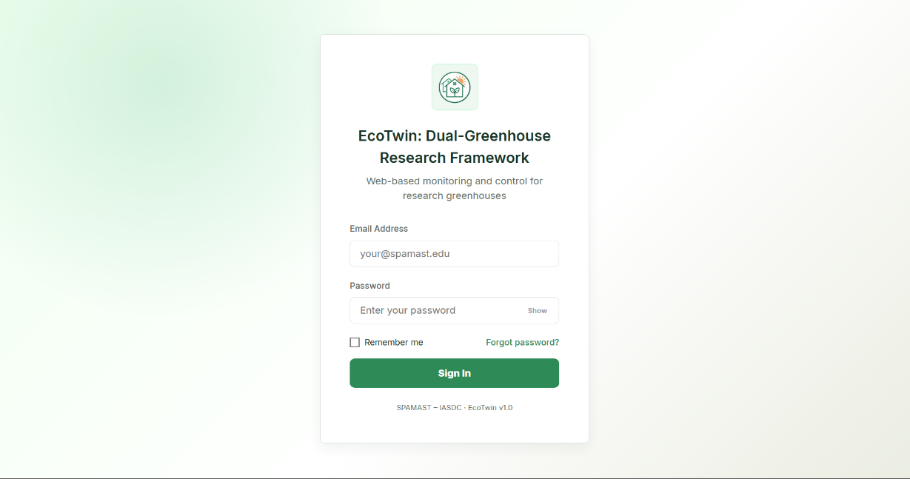
Fig. 9 shows the login interface of this project web system, which serves as the initial access point for administrators, researchers, and students. The interface displays the system title, brief description, and a centralized login card containing fields for username or email, password, and role selection, along with a sign-in button and optional “remember me” and “forgot password” controls, following patterns used in other web-based smart farm and greenhouse dashboards that emphasize secure and straightforward access. The layout is intentionally simple and uncluttered, enabling users to authenticate quickly from laboratory PCs or laptops; upon successful login, users are redirected to the main dashboard, while invalid credentials trigger an inline error message that guides them to retry without leaving the page.​
Fig. 9. Login Interface of ECOTwin: A Dual‑Greenhouse Vertical Farming System Designed for Experimental Researches

Fig. 10 presents the dashboard interface of the system web application, which functions as the central workspace for monitoring and managing both research greenhouses. The dashboard displays a global summary of active experiments, sensor connectivity, and recent alerts at the top, followed by tabbed greenhouse panels that show real-time readings for temperature, humidity, light, EC/TDS, pH, water level, and water temperature, alongside time-series charts and actuator status indicators for pumps, fans, and shading mechanisms. Administrators and researchers can access additional controls for configuring experiments and issuing manual actuator overrides, while students primarily use the dashboard to observe conditions and review historical trends, aligning the interface with role-based usage and dashboard usability criteria that highlight clarity, learnability, and situational awareness in monitoring environments.

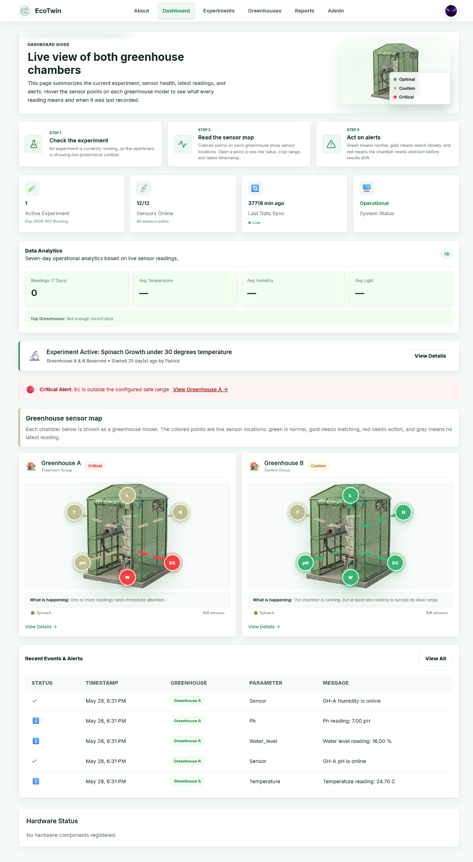
Fig. 10. Dashboard of ECOTwin: A Dual‑Greenhouse Vertical Farming System Designed for Experimental Researches
Hardware Design
Hardware design involves the structured selection and integration of physical components that enable this projects system to sense environmental conditions, execute control actions, and communicate with the web-based management interface. The platform combines microcontroller boards, wireless modules, and a suite of sensors including DHT22 temperature humidity, LDR light, PCB-type water level, DS18B20 water temperature, EC/TDS, and pH probes to capture critical greenhouse parameters that influence romaine lettuce growth, mirroring the sensor–actuator patterns used in other Arduino-based greenhouse prototypes [44]. Actuators such as submersible pumps, greenhouse fans, and relay-controlled power lines receive commands from the controllers to regulate irrigation, ventilation, and microclimate conditions, while a stabilized power supply, reflecting embedded-systems best practices where sensors act as the “eyes” and actuators as the “hands” of the control logic [45].
The functional requirements of this system hardware, describing how each physical component contributes to the overall operation of the dual-greenhouse research framework. The Arduino Uno and ESP32 modules serve as the primary controllers that coordinate sensor readings, actuator commands, and communication with the web-based interface, while wireless nRF modules support flexible deployment inside greenhouse structures. Environmental sensors including DHT22, LDR, water level, DS18B20, EC/TDS, and pH probes supply continuous measurements that inform irrigation and climate decisions, and relay-driven submersible pumps and greenhouse fans execute those decisions to maintain experimental conditions for romaine lettuce. Finally, the power supply underpins all operations, safe power delivery, helping the system behave predictably during fluctuations and aligning this project with established embedded-hardware design practices for smart greenhouse applications as shown in Table IV.​
TABLE IV
Functional Requirements for Hardware of the ECOTwin: A Dual‑Greenhouse Vertical Farming System Designed for Experimental Researches
Component / Module | Functional Requirement
Arduino Uno | This will be used as the primary microcontroller to read sensor inputs and control actuators for each greenhouse chamber.
Electrical Conductivity / Total Dissolved Solids Sensor | These will be used to measure electrical conductivity or total dissolved solids of the nutrient solution, indicating its concentration for plant growth.
Fans | These will be used to provide ventilation and air circulation inside the greenhouse, helping regulate temperature and humidity.
GSM Module (SIM800L) | This will be used to send SMS alerts directly via AT commands to researchers' phones when critical thresholds are exceeded or system anomalies detected, providing reliable communication redundancy independent of internet connectivity.
IASDC Faculty Personal Computer | This will be used as the deployment computer for hosting and running the ECOTwin web-based monitoring and management system within the IASDC office.
Light Sensor (Light Dependent Resistor) | This will be used to detect ambient light intensity in order to characterize lighting conditions affecting lettuce growth.
Microcontroller (ESP32) | This will be used to provide Wi-Fi connectivity, local processing, and communication between the greenhouse controller and the LAN-based data application.
Motor (28BYJ-48 Stepper Motor + ULN2003 Driver) | This will be used to provide precise automated retraction of shading nets based on light intensity (>800 lux) and temperature (>32°C) thresholds, enabling dynamic solar radiation control across the 73cm greenhouse depth with 4096 steps per revolution for exact positioning.
PCB Board | This will be used as the centralized interface integrating Arduino Uno, ESP32, relay modules, and sensors into a single, compact, reliable circuit board with proper power distribution, signal conditioning, and protection circuits for stable greenhouse operation.
pH Sensor Kits | These will be used to monitor the pH level of the nutrient solution and support adjustments to maintain optimal growing conditions.
Power Supply | This will be used to deliver stable power to all components.
Relay Modules | These will be used to switch pumps, fans, and other high-voltage devices safely using low-voltage control signals from the microcontroller.
Submersible Pump | This will be used to circulate or deliver water and nutrient solution to the plants according to the configured schedule or control logic.
Temperature–Humidity Sensor (DHT22) | This will be used to measure air temperature and relative humidity inside each greenhouse to monitor environmental conditions.
Water Level Sensor (Printed Circuit Board-Type) | This will be used to monitor nutrient solution or water level in the reservoir and trigger refilling or alerts when levels are low.
Waterproof Temperature Sensor (DS18B20) | This will be used to measure water or nutrient solution temperature to ensure it remains within the desired range.
Non-Functional Requirement
The non-functional requirements of the hardware establish the performance standards and operational qualities that ensure this project physical components function dependably in a humid, outdoor-adjacent greenhouse environment. These include attributes such as durability, power efficiency, reliability, and safety, which collectively determine how the hardware behaves beyond its basic sensing and actuation functions. Defining these parameters helps ensure that sensors, microcontrollers, pumps, and fans can operate for extended periods, withstand typical greenhouse conditions, and recover gracefully from power or network fluctuations, similar to other Arduino-based greenhouse projects that emphasize robust enclosures, stable power, and long-term continuous operation [44].These requirements also reflect guidance from IoT-focused frameworks that highlight energy-conscious design, fault tolerance, and protection of field-deployed devices as critical for sustainable and resilient smart agriculture infrastructure [46].
The non-functional requirements of the system hardware, highlighting the quality attributes that ensure stable and dependable system performance. The Durability requirement ensures that all boards, sensors, and actuators are physically protected and suitable for greenhouse exposure, reducing the risk of corrosion or premature failure. Power Efficiency focuses on minimizing unnecessary energy use so that pumps, fans, and controllers can run for long periods without excessive consumption, supporting sustainable operation in line with green IoT principles. Reliability emphasizes continuous, error-free operation through good wiring practice, sensor calibration, and robust mounting, while Safety guarantees that all electrical components are installed and protected to avoid shocks, shorts, or unsafe heat buildup, making the system suitable for use in student and research laboratory environments as shown in Table V.
TABLE V
Non-Functional Requirements for Hardware of the ECOTwin: A Dual‑Greenhouse Vertical Farming System Designed for Experimental Researches
Component / Module | Non-Functional Requirement
Durability | - The hardware will be able to withstand typical greenhouse conditions including elevated humidity, temperature fluctuations, and occasional water exposure by using appropriate enclosures, mounting, and corrosion-resistant materials, helping maintain long-term sensor accuracy and actuator performance [44].
Power Efficiency | - The hardware will be able to optimize energy consumption by using suitable power supplies, efficient pumps and fans, and low-power communication modes where feasible, supporting sustainable operation and aligning with energy-efficient IoT guidelines that reduce waste and operating cost [46].
Reliability | - The hardware will be able to perform consistently over extended periods by maintaining stable microcontroller operation, minimizing loose connections, and ensuring accurate, calibrated sensors, so that environmental control remains dependable for entire crop cycles and continuous experiments [44].
Safety | - The hardware will be able to operate without posing electrical or mechanical hazards to users by implementing proper insulation, fusing, grounding, and relay isolation for mains-powered devices, in line with safety considerations described in IoT-based building and greenhouse implementations [47].

Circuit Diagram
The circuit diagram provides an overview of the electrical layout and interactions among the project’s hardware components, illustrating how microcontrollers, sensors, actuators, communication modules, and power systems are connected to enable greenhouse monitoring and control. It highlights the general relationships between processing units, various environmental and water quality sensors, relay-controlled devices, and the regulated power supply. Such schematics are commonly used in ESP32- and Arduino-based smart greenhouse projects to guide wiring, signal flow, and safe integration of sensors and actuators, while supporting troubleshooting and system assembly [44].
Fig. 11 illustrates the circuit diagram of this project, showing how the Arduino Uno and ESP32 act as central controllers that connect to the various sensors and actuators deployed in the two research greenhouses. The DHT22, LDR, water level sensor, DS18B20, EC/TDS, and pH modules are wired to the Arduino and ESP32 input pins with shared 5 V or 3.3 V power rails and common ground, while relay modules are connected to digital output pins to switch the submersible pumps and greenhouse fans using isolated high-voltage circuits, a pattern consistent with published ESP32–DHT22–relay tutorials and IoT greenhouse reference designs [47]. The nRF wireless modules are linked to the controllers via SPI pins to support optional wireless node extensions, and the entire assembly is powered by a regulated supply with UPS backup that feeds the logic-level electronics and the relay-driven loads separately, ensuring both electrical safety and continuous operation under typical greenhouse conditions.​

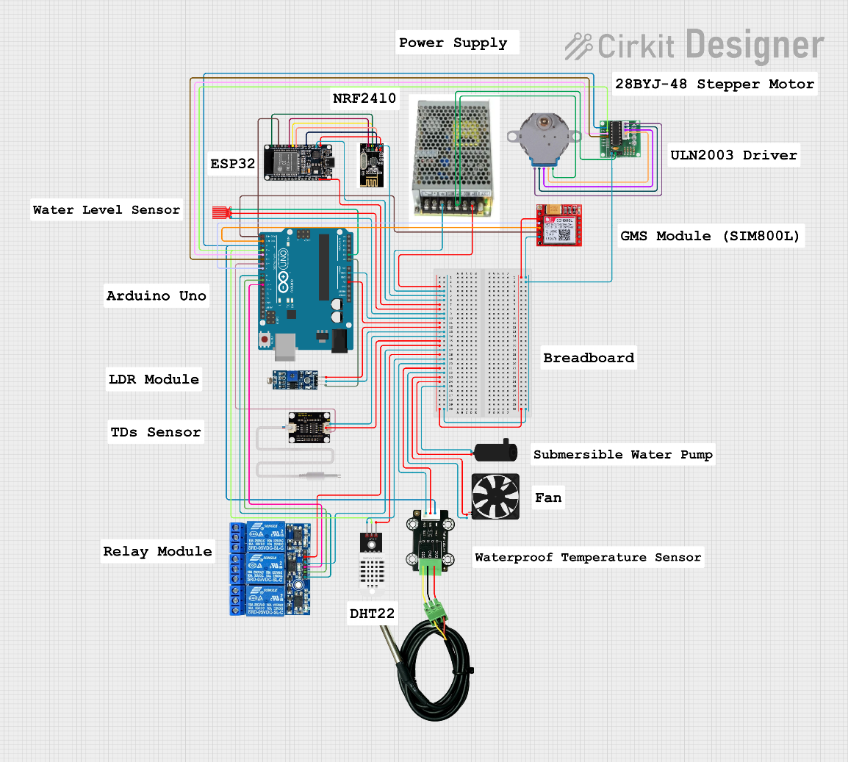
Perspective Diagram
Fig. 11. Circuit Diagram of ECOTwin: A Dual‑Greenhouse Vertical Farming System Designed for Experimental Researches
The perspective diagram illustrates the physical configuration and visual structure of the project prototype, showing how the dual greenhouse tents, vertical PVC racks, sensor assemblies, controller boxes, and plumbing are arranged to support research workflows and maintenance. It depicts the placement of romaine lettuce channels on stacked levels, the routing of irrigation lines and return drains, and the mounting of environmental sensors at representative canopy and reservoir positions, similar to schematic and 3D views used in other smart greenhouse and vertical farming designs that emphasize spatial integration of grow structures with control hardware [48]. By providing a three-dimensional view of the project layout, the perspective diagram helps designers and users evaluate clearances, airflow paths, cable routing, and access for calibration or repairs, bridging the gap between the abstract system architecture and the practical, ergonomic considerations of operating a dual-greenhouse research setup in a constrained campus space.
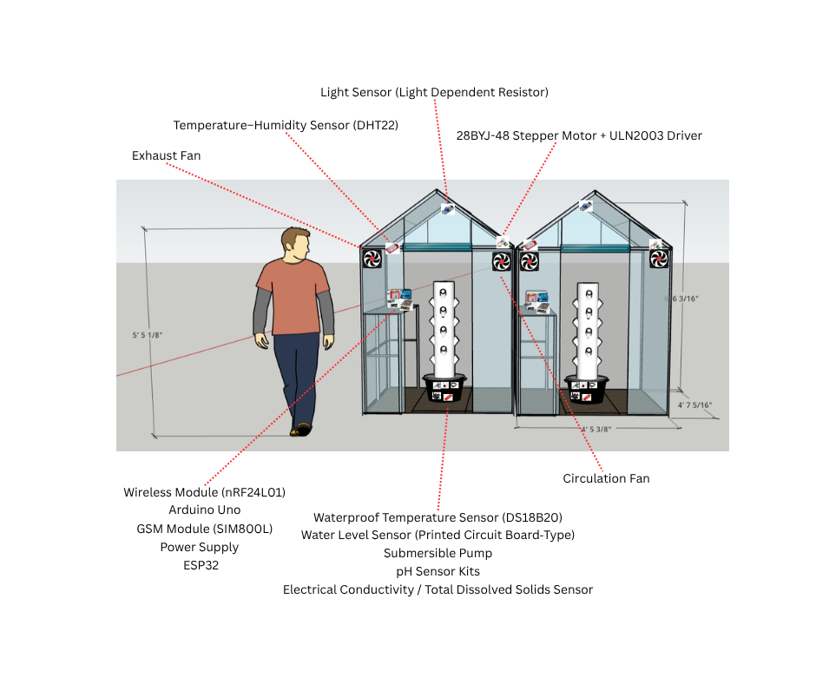
Fig. 12 presents the front view perspective diagram of the project, highlighting two compact greenhouse structures positioned side by side, each containing vertically stacked PVC pipe or gutter channels planted with romaine lettuce. From this viewpoint, the door or access flap of each greenhouse, the vertical arrangement of the grow levels, and the visible sensor housings mounted near plant canopies and along the reservoir area are shown, reflecting typical front-elevation illustrations used in controlled-environment agriculture projects to plan crop access, lighting exposure, and equipment placement [49]. The front view also indicates the approximate location of the controller enclosure and main power/UPS box at the base or between the greenhouses, ensuring that cabling and irrigation lines are organized while keeping electronic components reasonably protected from spray and high humidity.​
Fig. 12. Perspective Diagram (Front View) of ECOTwin: A Dual‑Greenhouse Vertical Farming System Designed for Experimental Researches
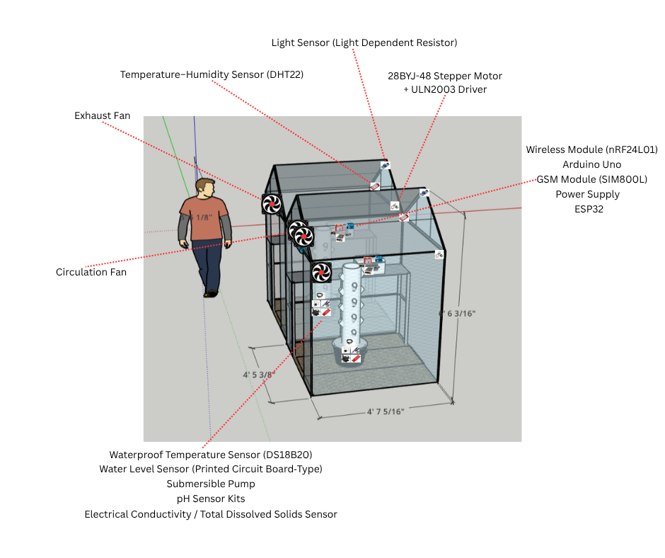
Fig. 13 shows the side view perspective diagram of one 143 cm × 73 cm × 195 cm Woodside mini-greenhouse, emphasizing the depth and vertical spacing of the stacked cultivation levels and the airflow patterns driven by the installed 120 × 120 mm exhaust fan and circulation fan for ventilation. This view illustrates how shelves or pipe tiers extend from front to back within the 73 cm depth constraint, how the 120 × 120 mm exhaust fan and circulation fan are mounted near the upper section to move warm air out and draw cooler air in according to greenhouse fan-sizing guidance based on greenhouse volume and air exchange rate, and how shading materials may be positioned above or along the side to modulate incoming solar radiation, consistent with side-elevation drawings used in vertical farming and passive solar greenhouse design to evaluate light gradients and ventilation strategies [50]. The side view also indicates sensor positions along the vertical profile, helping researchers understand how data reflects microclimate differences between upper and lower levels within each greenhouse.
Fig. 13. Perspective Diagram (Side View) of ECOTwin: A Dual‑Greenhouse Vertical Farming System Designed for Experimental Researches
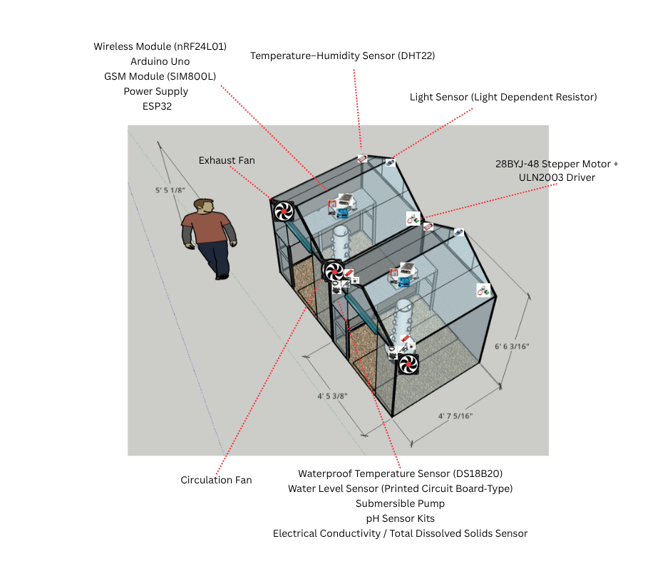
Fig. 14 presents the top view perspective diagram of the project prototype, illustrating the plan layout of the two 143cm × 73cm × 195cm Woodside walk-in greenhouses , main nutrient reservoirs, controller enclosures, and primary cable and pipe routes. From above, the diagram shows the 1.04 m² footprint of each commercial mini-greenhouse, the arrangement of vertical rack columns optimized for the 73cm depth, and the placement of reservoirs and plumbing paths that connect pumps to the grow channels and return drains back to the tanks echoing plan-view schematics used in compact greenhouse layout studies to optimize workflow within constrained research spaces . The top view also clarifies technician access paths (143cm width enables standing entry), sensor hub locations along rack columns, and LAN/power feed entry points supporting organized installation and future scalability of this validated prototype hardware [51].
Fig. 14. Perspective Diagram (Top View) of ECOTwin: A Dual‑Greenhouse Vertical Farming System Designed for Experimental Researches
Design Feasibility
The design feasibility of “ECOTwin: A Dual‑Greenhouse Vertical Farming System Designed for Experimental Researches” is supported by the availability of low-cost microcontrollers, sensors, and communication modules that have already been validated in similar smart greenhouse and hydroponic prototypes, demonstrating that reliable environmental monitoring and automation can be achieved using Arduino-based architectures and off-the-shelf components. Studies on IoT-based smart and economic greenhouses show that integrating temperature, humidity, light, and nutrient monitoring with automated control reduces manual labor, stabilizes growing conditions, and improves productivity all with investment levels suitable for small producers and educational institutions [52]. Likewise, low-cost greenhouse IoT architectures and Philippine smart greenhouse hydroponics projects for lettuce confirm that LAN- or Wi-Fi–connected sensing and control systems can be implemented in local contexts using open-source hardware and software, reinforcing the technical and economic viability of deploying this project as a dual-greenhouse research framework at SPAMAST Buhangin Campus for romaine lettuce experimentation and student training.

Technical Feasibility
Technical feasibility assesses whether this project can be implemented using readily available hardware, software, and network infrastructure that are compatible with local conditions and institutional capabilities. The proposed design relies on widely used microcontrollers and standard actuators that have been successfully deployed in numerous IoT-based greenhouse and mini-greenhouse prototypes in the Philippines and abroad, demonstrating that these components can reliably support real-time monitoring and control in small-scale controlled-environment agriculture [53]. On the software side, using Arduino IDE for firmware, alongside Visual Studio 2022 and phpMyAdmin for the web backend and database, leverages established development tools with extensive documentation and community support, aligning the system with technology stacks already adopted in web-based smart farm and greenhouse systems. Because all key requirements are met through off-the-shelf, locally or online procurable components and mainstream software platforms, the system is technically feasible to build, deploy, and maintain within the capabilities of SPAMAST students and faculty.​The technical requirements availability for this project, indicating that both hardware and software components can be sourced through common commercial channels or free official downloads. Most electronic parts such as microcontrollers, sensors, relays, pumps, and fans are obtainable through local or regional suppliers and established e-commerce platforms within one to two weeks, aligning with lead times reported in similar IoT greenhouse projects that rely on off-the-shelf components. Development tools including Visual Studio 2022, Arduino IDE, and phpMyAdmin are freely or readily accessible online, further strengthening the system’s technical feasibility for a student-led implementation in a university environment as shown in Table VI.
TABLE VI
Technical Requirements Availability of the ECOTwin: A Dual‑Greenhouse Vertical Farming System Designed for Experimental Researches
Requirement | Source | Acquisition Time
Arduino Uno | Electronics suppliers (online) | 5-7 days
DHT22 Temperature–Humidity Sensor | Electronics suppliers (online) | 5-7 days
DS18B20 Waterproof Temperature Sensor | Electronics suppliers (online) | 5-7 days
EC/TDS Modules | Electronics suppliers (online) | 5-7 days
ESP32 Module | Electronics suppliers (online) | 5-7 days
Fans | Electronics suppliers (online) | 5-7 days
GSM Module (SIM800L) | Electronics suppliers (online) | 5-7 days
Light Sensor (LDR Module) | Electronics suppliers (online) | 5-7 days
nRF Wireless Module | Electronics suppliers (online) | 5-7 days
28BYJ-48 Stepper Motor + ULN2003 Driver | Electronics suppliers (online) | 5-7 days
PCB Board | Electronics suppliers (online) | 5-7 days
pH Sensor Kits | Electronics suppliers (online) | 5-7 days
Power Supply | Electronics suppliers (online) | 5-7 days
Relay Modules | Electronics suppliers (online) | 5-7 days
Submersible Pump | Electronics suppliers (online) | 5-7 days
Arduino IDE | Microsoft | Immediate (download)
phpMyAdmin | XAMP | Immediate (download)
Visual Studio 2022 | Arduino | Immediate (download)

Operational Feasibility
Operational feasibility evaluates whether this project can be successfully adopted and sustained within SPAMAST’s instructional and research routines, considering user skills, workload, and institutional processes. Experiences from IoT smart greenhouse hydroponics projects for lettuce in the Philippines and similar educational prototypes show that faculty, students, and farm staff can operate automated monitoring and control systems effectively after brief training, gaining better oversight of pH, EC, temperature, and water flow while improving yield and data quality [29]. Because this system uses a web-based dashboard, simple status indicators, and automated actuation, its day-to-day operation primarily involves routine checks, occasional parameter adjustments, and basic maintenance activities that are well aligned with laboratory classes and capstone projects, supporting sustainable use without imposing excessive additional workload on instructors and technicians [31].​
The operational feasibility assessment of this project in terms of performance, information handling, economics, and control. Under performance, the system addresses unstable microclimates and variable lettuce growth by automating sensing and control, allowing experiments to run closer to their intended treatment conditions. In terms of information, the system replaces fragmented, manual records with structured, quarriable data that improves documentation and supports richer analysis for students and researchers. From an economic perspective, reduced manual monitoring and more efficient use of water and nutrients can offset the modest cost of hardware while adding instructional value to greenhouse activities as shown in Table VII.

TABLE VII
Operational Feasibility of the ECOTwin: A Dual‑Greenhouse Vertical Farming System Designed for Experimental Researches
 | Problem | Opportunities | Cause(s) | Effects(s)
Performance | Manual greenhouse monitoring at SPAMAST relies on periodic checks, making it difficult to maintain stable temperature, humidity, and nutrient conditions for romaine lettuce experiments. | ECOTwin can automate data collection and basic climate control, improving consistency of experimental conditions and plant performance. | Limited automation and lack of continuous sensing/control infrastructure in current school setups. | Fluctuating microclimate and inconsistent growth reduce reliability of research results and learning outcomes.
Information | Environmental and growth data are recorded sporadically on paper or spreadsheets, leading to incomplete or hard-to-reuse datasets. | ECOTwin web-based dashboard and database can centralize, timestamp, and visualize sensor data for classes, capstone work, and faculty research.​ | Absence of integrated sensing and information systems for greenhouse experiments. | Missed trends, weak documentation, and limited evidence for decision-making in controlled-environment agriculture teaching.
Economics | Frequent manual monitoring and corrective actions consume faculty and student time without fully optimizing water, nutrients, or energy use.​ | Automation and timely alerts from ECOTwin can reduce wasted inputs and labor while supporting higher, more predictable yields in student projects.​ | Inefficient monitoring practices and reactive rather than proactive environmental management.​ | Higher operational effort per experiment and underutilized potential of small greenhouse facilities.​
Control | Instructors have limited real-time visibility and delayed response capability when environmental parameters drift outside target ranges. | ECOTwin provides near real-time monitoring, threshold-based actuation, and alerting that enhance control over greenhouse conditions during and between classes. | Lack of integrated IoT platform for monitoring and control, especially during off-hours.​ | Increased risk of undetected parameter excursions, leading to crop stress, experiment failure, or inconsistent data.

Economic Feasibility
Economic feasibility examines whether the expected benefits of deploying this project justify its total lifecycle cost, considering hardware, software, and maintenance over several years. IoT-based smart and economic greenhouse studies show that modest investments in sensors, controllers, and automation can be offset by improved yield stability, reduced labor, and better resource use, particularly in small research and training facilities [53]. For this project, the cost structure is dominated by one-time purchases of controllers, sensors, pumps, fans, and power protection, with relatively low annual maintenance, while benefits accrue through labor savings in manual monitoring, reduced wastage of water and nutrients, and enhanced instructional and research value patterns consistent with prior cost–benefit assessments of mini-greenhouse and smart hydroponic installations for lettuce. Using a discounted cash flow approach over a three-year horizon with a moderate discount rate, this project yields a positive net present value and a favorable return on investment, indicating that the project is economically viable for SPAMAST as a teaching and research infrastructure.​
The cost–benefit and ROI analysis for this project in over a three-year horizon, showing that discounted benefits from improved monitoring efficiency and reduced manual workload outweigh discounted costs. With a total discounted cost of about ₱30,440.00 and discounted benefits of about ₱46,980.00, the system achieves a positive ROI and recovers its investment within the analysis period, consistent with other smart greenhouse studies that report rapid payback and sustained gains from modest IoT automation in small-scale agriculture and educational settings as shown in Table VIII.
TABLE VIII
Economic Feasibility (Cost–Benefit and Roi) of the ECOTwin: A Dual‑Greenhouse Vertical Farming System Designed for Experimental Researches
Discount Rate (DR)
 | Year 0 | Year 1 | Year 2 | Year 3 | Total
Cost (₱) | 24,790 | 4,000 | 4,000 | 4,000 | 36,790
Discount factor | 1.00 | 0.93 | 0.87 | 0.81
Discount Cost (₱) | 24,790 | 3,720 | 3,480 | 3,240 | 35,230
Benefits (₱) | – | 20,000 | 20,000 | 20,000 | 60,000
Discount factor | 1.00 | 0.93 | 0.87 | 0.81
Discounted benefit (₱) | – | 18,600 | 17,400 | 16,200 | 52,200
Cumulative benefit (₱) | – | -24,790 | -9,910 | 4,010
RIO |  |  |  |  | 0.54

Formula
ROI | = (DB-DC)/DC*100
Where | DB- Discounted Benefit DC- Discount

The detailed cost breakdown for this project, including initial hardware and development expenses in Year 0 and recurring maintenance costs in subsequent years. The estimates reflect realistic local pricing for microcontrollers, environmental sensors, actuators, and supporting materials, aligned with other low-cost greenhouse IoT implementations that emphasize affordability for small-scale systems as shown in Table IX.​
TABLE IX
Economic Feasibility (Cost Per Unit) of the ECOTwin: A Dual‑Greenhouse Vertical Farming System Designed for Experimental Researches
Unit | Cost per unit
 | Year 0 | Year 1 | Year 2 | Year 3
Arduino Uno | 500.00
DHT22 sensor | 220.00
DS18B20 waterproof | 200.00
EC/TDS module | 315.00
ESP32 module | 385.00
Fans | 1290.00
GSM Module (SIM800L) | 390.00
LDR light sensor module | 70.00
nRF wireless module | 200.00
28BYJ-48 Stepper Motor + ULN2003 Driver | 200.00
PCB Board | 70.00
pH sensor kit | 2,200.00
Power supply | 620.00
Relay module 4-ch 5V | 175.00
Submersible pump | 790.00
Water level sensor (PCB) | 80.00
Software Development | 10,000.00
Annual Maintenance | 10,000.00 | 4,000.00 | 4,000.00 | 4,000.00
Total | 20,000.00 | 4,000.00 | 4,000.00 | 4,000.00

The estimated annual benefit from this project in terms of operational efficiency, primarily due to reduced manual monitoring time and more structured data collection. While the monetary estimate focuses on workload savings, additional non-monetized benefits such as higher experiment success rates, better student learning outcomes, and improved institutional research capacity further strengthen the economic justification, mirroring findings from IoT greenhouse hydroponics and smart agriculture projects that highlight both financial and educational returns. The estimated annual benefit of ₱18,000.00, derived from a conservative assumption that automating environmental monitoring, logging, and basic control frees about 15% of one staff-equivalent’s workload per year (₱10,000 × 12 × 0.15). Evidence from IoT smart greenhouse deployments for hydroponic lettuce indicates that automation substantially reduces time spent on routine measurements and manual system checks, allowing staff to concentrate on higher-value tasks such as experiment design, data interpretation, and student supervision [29]. Broader smart-agriculture and digital-transformation studies likewise report that integrating sensors, real-time dashboards, and automated control reduces repetitive manual work, improves process efficiency, and supports more productive use of limited human resources, supporting the conservative nature of the 15% workload-reduction basis used in this computation as shown in Table X.​​
TABLE X
Economic Feasibility (Benefit Per Year) of the ECOTwin: A Dual‑Greenhouse Vertical Farming System Designed for Experimental Researches
Benefit per year when using the system | Computation | Annual Value
Operational efficiency gain (reduction of 0.15 full-time staff-equivalent dedicated to manual greenhouse monitoring and data logging; assumed salary ₱10,000 per month × 12 months × 0.15 workload share) | 10,000 × 12 × 0.15 | 18,000.00
Total |  | 18,000.00

IMPLEMENTATION
The implementation phase for “ECOTwin: A Dual‑Greenhouse Vertical Farming System Designed for Experimental Researches” focuses on translating the designed dual-greenhouse architecture into a working system through structured hardware assembly, firmware development, web application deployment, and iterative testing. Implementation begins with constructing or preparing the two compact greenhouse structures, installing vertical racks, mounting sensors, and wiring actuator to the Arduino Uno and ESP32 controllers, following stepwise build practices documented in prior Arduino- and ESP32-based greenhouse projects , [54]. In parallel, firmware is developed and uploaded via the Arduino IDE to handle sensor reading, local decision logic, and communication, while the web-based dashboard and database back end are implemented and deployed on a LAN-connected server, similar to IoT greenhouse systems that use staged rollouts bench testing, single-greenhouse pilot, and full deployment to validate reliability before continuous operation [29]. Once the integrated system is operational, the implementation phase concludes with user training for faculty and students, documentation of standard operating procedures, and initial experimental runs to confirm that this project meets its monitoring, control, and research support objectives in the SPAMAST context.
Work Breakdown Structure
Implementation for this project is organized using a Work Breakdown Structure (WBS) that decomposes the project into manageable phases and tasks covering planning, hardware assembly, software development, integration, testing, and documentation. A structured WBS helps the team assign responsibilities, estimate timelines, and track progress while ensuring that all deliverables dual greenhouses, embedded controllers, web dashboard, and supporting documentation are completed systematically, similar to smart greenhouse and agricultural IoT projects that rely on phased breakdowns for successful delivery [44].​
The Work Breakdown Structure (WBS) for implementing the system dual-greenhouse research framework, outlining the major tasks from planning through deployment and training. The WBS decomposes the project into sequential and parallel activities such as procurement and assembly, firmware and web development, integration, calibration, and pilot testing so that responsibilities and timelines are clearly defined and manageable. Using a WBS in this way supports better project control and communication, mirroring approaches in other smart greenhouse and agricultural IoT projects where structured breakdowns are used to coordinate technical work, field installation, and validation activities as shown in Table XI.
TABLE XI
Work Breakdown Structure of the ECOTwin: A Dual‑Greenhouse Vertical Farming System Designed for Experimental Researches
Task | Dependency/ies | Target Date to Accomplish | Actual Accomplish Date | Responsible Person
- Project Planning and Requirements Finalization | - | 03/01/26 | 03/11/26 | Proponent/Adviser
- Define project scope, objectives, and success criteria for “ECOTwin: A Dual‑Greenhouse Vertical Farming System Designed for Experimental Researches”. | 1 | 03/01/26 | 03/11/26 | Proponent/Adviser
- Confirm technical requirements (sensors, controllers, web stack, LAN) | 1 | 03/01/26 | 03/11/26 | Proponent
- Develop initial schedule and risk register for greenhouse implementation. | 1 | 03/01/26 | 03/11/26 | Proponent
- Hardware Procurement and Assembly | 1 | 06/15/26 | - | Proponent
- Procure Arduino Uno, ESP32, nRF modules, sensors, pumps, fans, relays, and power/UPS | 2 | 06/15/26 | - | Proponent
- Prepare dual-greenhouse structures, racks, and mounting locations for hardware. | 2 | 06/15/26 | - | Proponent
- Assemble and wire sensor and actuator circuits according to the circuit diagram. | 2 | 06/15/26 | - | Proponent
- Embedded Firmware Development | 1 | 06/22/26 | - | Proponent
- Develop Arduino/ESP32 firmware for sensor data acquisition and local control logic. | 3 | 06/22/26 | - | Proponent
- Implement communication routines (serial/Wi-Fi/nRF) to send data to the web server. | 3 | 06/22/26 | - | Proponent
- Bench-test firmware with selected sensors and actuators before field deployment. | 2.3, 3.2 | 06/22/26 | - | Proponent
- Web Application and Database Development | 1 | 04/13/26 | - | Proponent
- Design database schema and configure phpMyAdmin environment. | 4 | 04/13/26 | - | Proponent
- Develop backend APIs/services for receiving sensor data and issuing control commands. | 4.1 | 04/13/26 | - | Proponent
- Implement web UI modules for login, dashboards, experiment and greenhouse management. | 4.1 | 04/13/26 | - | Proponent
- System Integration and Configuration | 2.3, 3.3, 4.3 | 06/22/26 | - | Proponent
- Deploy controllers and connect them to the LAN and web server. | 5 | 06/22/26 | - | Proponent
- Map sensor and actuator endpoints to database entries and dashboard views. | 5 | 06/22/26 | - | Proponent
- Configure initial thresholds, experiment profiles, and test accounts. | 5 | 06/22/26 | - | Proponent
- Testing, Calibration, and Validation | 5 | 08/03/26 | - | Proponent
- Calibrate sensors (pH, EC/TDS, temperature, humidity) and verify readings. | 6 | 08/03/26 | - | Proponent
- Conduct functional tests of automated control (pump/fan responses to thresholds). | 6.1 | 08/03/26 | - | Proponent
- Perform pilot lettuce run to validate data logging, dashboards, and alerts. | 6.2 | 08/03/26 | - | Proponent/Adviser

INTEGRATION, TEST, AND VERIFICATION
The integration, test, and verification phase ensures that “ECOTwin: A Dual‑Greenhouse Vertical Farming System Designed for Experimental Researches” hardware, embedded firmware, web application, and database operate as a cohesive system that meets the specified functional and non-functional requirements. Integration begins by connecting the Arduino/ESP32 controllers, sensors, actuators, and LAN-based server so that real-time measurements and control commands flow correctly between the greenhouses and the web dashboard, similar to IoT greenhouse implementations where sensors, gateways, and user interfaces are combined into layered architectures for continuous monitoring and actuation [55]. Once integrated, the system undergoes structured testing starting with unit tests on sensors and actuators, followed by integration tests across communication and data-logging paths, and finally scenario-based tests with live plants to verify that readings are accurate, thresholds trigger the expected responses, alerts are delivered, and data is stored reliably, echoing validation procedures used in intelligent greenhouse monitoring studies that compare system outputs with reference instruments and expected control behavior [29].​
Testers
The system will be evaluated by a focused group of academic stakeholders who can assess both the technical operation and its suitability as a research and teaching tool. Information Technology (IT) faculty members will exercise the system’s interfaces, data handling, and control functions, while panel members will review the system’s alignment with project objectives, methodological rigor, and overall usability for student research, consistent with HOT-Fit–inspired evaluations that involve both technical and organizational perspectives [56].
The distribution of testers for the system evaluation, composed of 12 Information Technology (IT) faculty members and 2 panel members. The inclusion of all IT faculty members ensures that the system will be assessed by users with relevant technical and academic expertise, while the panel members provide additional evaluation on the system’s research relevance, functionality, and overall acceptability. This full enumeration of the available expert respondents supports a more credible and comprehensive validation process, especially in studies where expert judgment is essential as shown in Table XII.
TABLE XII
Distribution of Testers of the ECOTwin: A Dual‑Greenhouse Vertical Farming System Designed for Experimental Researches
Tester | Population | Sample Size
1. Information Technology (IT) Faculty | 12 | 12
2. Panel Members | 2 | 2
TOTAL | 14 | 14

Unit and Integration Test Plan
The unit and integration test plan for the system defines how individual hardware and software components, and their interactions, will be tested to ensure that each module functions correctly on its own and as part of the complete dual-greenhouse system. Unit tests focus on verifying that microcontrollers, sensors, actuators, communication modules, and web application features behave according to their specifications, while integration tests confirm that data flows, control commands, and database operations work reliably across subsystem boundaries, reflecting practices used in other IoT smart greenhouse projects where structured testing is essential to validate environmental monitoring and automated control [44].​
The unit test plan for the system, detailing how each hardware and web application component will be tested individually to confirm that it performs its intended function. Hardware unit tests verify that sensors, actuators, communication modules, and power systems operate correctly, while software unit tests focus on authentication, dashboards, experiment management, monitoring, automated control, notifications, reporting, and administration. This systematic component-level testing approach is consistent with IoT greenhouse and smart farming projects that emphasize early fault detection and module-level verification before full system integration as shown in Table XIII.
TABLE XIII
Unit Test Plan of the ECOTwin: A Dual‑Greenhouse Vertical Farming System Designed for Experimental Researches
System | Subsystem | Test Component | Test Case | Test Case ID
ECOTwin: A Dual-Greenhouse Vertical Farming System Designed for Experimental Researches | Hardware Subsystem | Arduino Uno | The system shall process input signals from connected sensors and output control signals to actuators assigned to each greenhouse unit. | UT-01
 |  | ESP32 Module | The system shall receive sensor data from Arduino-based nodes, manage Wi-Fi connectivity, and transmit greenhouse readings and actuator states to the web server. | UT-02
 |  | GSM Module / SIM800L | The system shall send SMS alerts when critical environmental thresholds are exceeded or when Wi-Fi communication fails. | UT-03
 |  | nRF Wireless Module | The system shall transmit and receive sensor and actuator data between distributed greenhouse nodes and the main controller with minimal packet loss. | UT-04
 |  | DHT22 Temperature and Humidity Sensor | The system shall measure air temperature and relative humidity within the expected sensor accuracy and forward readings to the controller at configured intervals. | UT-05
 |  | Light Sensor / LDR Module | The system shall detect changes in light intensity and provide corresponding analog or digital values to the microcontroller for monitoring and shading decisions. | UT-06
 |  | 28BYJ-48 Stepper Motor with ULN2003 Driver | The system shall move the shading net to the required position when triggered by light or temperature thresholds. | UT-07
 |  | Water Level Sensor | The system shall detect low and normal water or nutrient solution levels and notify the controller when the defined threshold is reached. | UT-08
 |  | DS18B20 Waterproof Temperature Sensor | The system shall measure nutrient solution temperature and return accurate digital readings to the controller. | UT-09
 |  | EC/TDS Sensor Module | The system shall measure the electrical conductivity or total dissolved solids of the nutrient solution and convert the reading into usable monitoring values. | UT-10
 |  | pH Sensor Kit | The system shall measure the pH level of the nutrient solution and send the value to the controller for database logging and threshold checking. | UT-11
 |  | Relay Module | The system shall safely switch connected actuators such as pumps and fans on or off based on controller signals. | UT-12
 |  | Submersible Pump | The system shall circulate nutrient solution through the hydroponic channels when activated and stop circulation when deactivated. | UT-13
 |  | Exhaust or Cooling Fans | The system shall provide airflow when activated by the controller and stop operation when deactivated. | UT-14
ECOTwin | Web Management Interface | Authentication Module | The system shall authenticate authorized users using valid login credentials before allowing access to dashboard, monitoring, control, and configuration pages. | UT-15
 |  | Dashboard Module | The system shall display real-time sensor readings, actuator status, alert status, and shading net condition for each greenhouse unit. | UT-16
 |  | Greenhouse Management Module | The system shall allow greenhouse records to be created, updated, viewed, and associated with the correct hardware unit. | UT-17
 |  | Experiment Management Module | The system shall allow users to create, update, close, and view experiments assigned to specific greenhouse units. | UT-18
 |  | Environmental Monitoring Module | The system shall retrieve stored sensor data and present historical readings, graphs, and status indicators per parameter and greenhouse. | UT-19
 |  | Automated Control Module | The system shall evaluate sensor readings against configured thresholds and generate appropriate control actions for pumps, fans, and shading motors. | UT-20
 |  | Notification Module | The system shall generate and display alerts when environmental readings exceed thresholds or when communication errors occur. | UT-21
 |  | SMS Alert Logging | The system shall record SMS alert events sent through the GSM module, including alert type, greenhouse source, date, and time. | UT-22
 |  | Data Export and Reporting Module | The system shall export selected experiment and sensor data into CSV or report format for research analysis. | UT-23
 |  | User and Administrator Module | The system shall allow authorized administrators to manage user accounts, roles, and access permissions. | UT-24

The integration test plan for the system, outlining the key interactions between hardware, web interface, database, and control/notification modules that must be validated to ensure end-to-end system reliability. The tests confirm that sensor data flows correctly from the greenhouses to the database and dashboards, that configuration and control commands propagate back to the hardware, and that user roles, experiment settings, and alerts are handled consistently across subsystems. This integration-focused strategy mirrors the verification practices of other IoT-based smart greenhouse solutions, where coordinated testing of communication paths and control loops is essential for achieving robust real-time environmental monitoring and plant-growth optimization as shown in Table XIV.
TABLE XIV
Integration Test Plan of the ECOTwin: A Dual‑Greenhouse Vertical Farming System Designed for Experimental Researches
System | Integration Area | Test Case | Test Case ID
ECOTwin | Sensor-to-Controller Integration | The system shall collect temperature, humidity, light, pH, EC/TDS, water level, and nutrient temperature readings from greenhouse sensors and transmit them to the controller without data mismatch. | IT-01
 | Controller-to-ESP32 Integration | The system shall transfer processed sensor readings and actuator states from the Arduino controller to the ESP32 module for server transmission. | IT-02
 | ESP32-to-Web Server Integration | The system shall send greenhouse data from the ESP32 to the web server through Wi-Fi and confirm successful data reception. | IT-03
 | Database Integration | The system shall store incoming sensor readings, actuator states, alerts, and experiment records in the correct database tables with the proper greenhouse identifier. | IT-04
 | Dashboard Integration | The system shall update the dashboard with the latest readings and actuator states from each greenhouse after new data is received. | IT-05
 | Automated Control Integration | The system shall compare incoming readings with configured thresholds and activate the appropriate actuator, such as fan, pump, or shading motor. | IT-06
 | Shading Net Control Integration | The system shall activate the stepper motor and adjust the shading net position when light intensity or temperature exceeds the configured threshold. | IT-07
 | Alert and Notification Integration | The system shall generate web notifications and SMS alerts when critical readings or communication failures are detected. | IT-08
 | Experiment Data Integration | The system shall link sensor readings and actuator activities to the active experiment assigned to the corresponding greenhouse. | IT-09
 | Dual-Greenhouse Comparison Integration | The system shall separately record, display, and compare data from Greenhouse 1 and Greenhouse 2 without mixing readings or control commands. | IT-10
 | Data Export Integration | The system shall export selected experiment data from the database into a readable file format for analysis and reporting. | IT-11
 | Communication Failure Handling | The system shall detect Wi-Fi or wireless module failure and trigger fallback alert procedures through the GSM module when applicable. | IT-12

SYSTEM VERIFICATION AND VALIDATION
System verification and validation for “ECOTwin: A Dual‑Greenhouse Vertical Farming System Designed for Experimental Researches” ensure that the implemented dual-greenhouse monitoring and control system conforms to its design specifications and meets the needs of its intended user’s faculty and BSIT students within the SPAMAST context. Verification activities focus on checking that each module satisfies the documented functional and non-functional requirements through structured unit and integration tests, similar to IoT smart greenhouse projects that validate reliability, functionality, and usability against standards such as ISO/IEC quality models [29]. Validation activities then gather feedback from actual or prospective users to determine whether this system is usable, useful, and appropriate for supporting romaine lettuce experiments and coursework, echoing evaluation approaches in greenhouse and smart-farming systems where user studies confirm that operators can perform monitoring and control tasks without extensive prior experience [31]. The evaluation is based on selected ISO/IEC 25010 software quality characteristics, namely Functionality, Reliability, Usability, Connectivity, and User Interface, to determine the overall quality, effectiveness, and acceptability of the system [57].
Respondents
The respondents for this system validation are BSIT students who represent the primary end-users of the system in laboratory exercises, capstone projects, and research activities. Involving first-, second-, and third-year BSIT students allows the evaluation to capture perceptions from users with varying levels of technical experience, consistent with usability and system-quality studies that recruit diverse student cohorts to assess educational technologies and IoT-based learning tools [57]. Their feedback on ease of use, interface clarity, information usefulness, and perceived benefits will be used to refine this system design and to confirm that the system effectively supports learning outcomes in networking, embedded systems, and web development courses.​
The distribution of BSIT student respondents selected for the system validation, with a total sample of 89 students drawn from a population of 114 enrollees across three-year levels. The sample was proportionately allocated across the three cohorts to ensure balanced representation of each group in the evaluation. This stratified approach is appropriate for validation studies because it helps capture feedback from users with different academic levels while maintaining fairness in respondent distribution as shown in Table XV.
TABLE XV
Distribution of Respondents of the ECOTwin: A Dual‑Greenhouse Vertical Farming System Designed for Experimental Researches
Respondents | Population | Sample Size
1st Year BSIT Students | 44 | 34
2nd Year BSIT Students | 36 | 28
3rd Year BSIT Students | 24 | 19
TOTAL | 114 | 89

Project Assessment Instrument
The project assessment instrument for this project is adapted from the evaluation framework used in the study “IoT-based Automated Greenhouse with Monitoring and Control using MQTT Protocol.” The system will be evaluated using selected quality characteristics derived from the ISO/IEC 25010 Software Quality Model, which is widely used for assessing the quality of software-integrated systems. [56].
The ISO/IEC 25010-based project assessment instrument adapted from the evaluation approach utilized in the study “IoT-based Automated Greenhouse with Monitoring and Control using MQTT Protocol.” The instrument measures the system's functionality, reliability, usability, connectivity, and user interface quality using a five-point Likert scale. These criteria assess both the web-based application and the integrated greenhouse hardware components, enabling respondents to evaluate the effectiveness, reliability, and overall quality of ECOTwin as a greenhouse monitoring and control system. The results will be used to determine the acceptability and performance of the developed system in supporting research and educational activities as shown in Table XVI.​
TABLE XVI
ISO/IEC 25010-Based Project Assessment of the ECOTwin: A Dual‑Greenhouse Vertical Farming System Designed for Experimental Researches
ISO/IEC 25010 | 5 | 4 | 3 | 2 | 1
FUNCTIONALITY
The system accurately displays greenhouse environmental parameters.
The system correctly records and updates sensor data from both greenhouses.
The system provides appropriate alerts and notifications when abnormal conditions occur.
The automated control functions operate correctly based on configured thresholds.
RELIABILITY
The system operates consistently without unexpected system failures or downtime.
The hardware and software components maintain stable and continuous communication during operation.
USABILITY
The web-based interface allows convenient monitoring and management of greenhouse conditions.
The system is easy to learn and operate for new users.
CONNECTIVITY
The connection between greenhouse hardware and the web application is stable.
Sensor data are transmitted reliably and displayed in the monitoring dashboard without delay.
USER INTERFACE
The system dashboard is clear, organized, and visually supports effective monitoring of greenhouse data.

Statistical Treatment and Analysis of Data
The statistical treatment of data will employ quantitative methods to analyze the responses gathered from the system evaluation questionnaires adapted from the assessment framework used by Bravo et al. (2021) and based on selected ISO/IEC 25010 software quality characteristics. Descriptive statistical tools such as weighted mean and frequency distribution will be used to summarize respondent feedback, allowing for an objective and systematic assessment of the system's functionality, reliability, usability, connectivity, and user interface quality [58]. This analytical approach ensures that the survey data yield valid and reliable insights regarding the acceptability and performance of the ECOTwin system.
The statistical treatment and analysis of data describe the methods used to interpret survey responses gathered through Likert-scale items administered to the selected respondents. Descriptive statistics, particularly weighted mean scores, will be employed to summarize central tendencies across the five major evaluation criteria: Functionality, Reliability, Usability, Connectivity, and User Interface. Complementary to this, frequency distribution analysis will be used to determine how often respondents selected each rating category on the five-point Likert scale (5 = Strongly Agree to 1 = Strongly Disagree), providing an overall assessment of the system's quality and acceptability while identifying variations in user perception.
Mean
The weighted mean will be used to determine the average response of respondents for each assessment indicator, computing a single representative value that summarizes the overall evaluation result and facilitates clearer interpretation of user feedback and system performance. By calculating the mean across all respondents and items within each evaluation criterion, the study can identify the general level of agreement toward specific system attributes such as ease of use, reliability of greenhouse monitoring functions, communication stability, and interface quality [59].​​
Frequency
Frequency distribution will be used to present how often each response category (5, 4, 3, 2, or 1) occurs within the dataset, helping identify patterns, trends, and the overall distribution of responses across the evaluation indicators. By summarizing how many respondents selected each rating on the Likert scale, frequency analysis provides a clear overview of respondent perceptions and supports meaningful interpretation of the results [60].​
Likert Scale for Acceptability
A five-point Likert scale will be used to measure the level of acceptability of the ECOTwin system based on respondents' perceptions, with ratings ranging from 5 (Strongly Agree) to 1 (Strongly Disagree). This measurement technique converts subjective opinions into quantifiable data, enabling the assessment of system quality, effectiveness, usability, reliability, and overall user acceptance [61].​
The five-point Likert scale used to interpret the results of the ISO/IEC 25010-based system evaluation. The scale provides the corresponding numerical range, verbal interpretation, and descriptive rating used to classify respondents' level of agreement with each assessment statement. A weighted mean ranging from 4.21 to 5.00 indicates a "Strongly Agree" rating, signifying that the system performs exceptionally well and meets or exceeds user expectations. Scores between 3.41 and 4.20 reflect an "Agree" rating, while scores ranging from 2.61 to 3.40 are interpreted as "Moderately Agree," indicating acceptable performance with opportunities for enhancement. Lower mean ranges of 1.81 to 2.60 ("Disagree") and 1.00 to 1.80 ("Strongly Disagree") suggest that substantial improvements are needed to enhance the system's overall quality, effectiveness, and user satisfaction as shown in Table XVII.
TABLE XVII
Likert Scale for Acceptability Assessment of the ECOTwin: A Dual‑Greenhouse Vertical Farming System Designed for Experimental Researches
Range | Verbal Interpretation | Descriptive Rating
4.21–5.00 | Strongly Agree | The system performs exceptionally well, meeting or exceeding expectations in all aspects.
3.41–4.20 | Agree | The system is reliable and effective, with only minor areas for improvement.
2.61–3.40 | Moderately Agree | The system functions adequately but may have some limitations or areas for enhancement.
1.81–2.60 | Disagree | The system has noticeable shortcomings that require adjustments to enhance usability.
1.00–1.80 | Strongly Disagree | The system fails to meet expectations, requiring significant modifications to ensure proper functionality.

OPERATION AND MAINTENANCE
Operation and maintenance for this project focus on sustaining reliable greenhouse monitoring and control through regular inspections, calibration, software updates, and user support. Because IoT-based greenhouse systems continuously collect data and drive actuators such as pumps and fans, a structured maintenance plan is necessary to prevent sensor drift, detect hardware issues early, and ensure that automation routines remain aligned with plant and experiment requirements over time [47]. Well-defined routines for checking connections, reviewing logs, and responding to faults mirror best practices in smart greenhouse and embedded monitoring systems, where preventive and corrective maintenance have been shown to reduce downtime and protect crop outcomes [62].
Work Breakdown Structure
The Work Breakdown Structure (WBS) for this project operation and maintenance organize recurring and as-needed tasks into logical groups: routine hardware maintenance, software maintenance and updates, system performance evaluation, emergency maintenance, and user training and support. This structured breakdown helps assign responsibilities to the proponent and laboratory technician, define periodicities, and ensure that critical activities such as sensor calibration, log review, and emergency repairs are not overlooked, following similar frameworks used in greenhouse monitoring and automation systems that emphasize ongoing support after deployment [55]. Regularly reviewing of this project performance and user feedback allows continuous improvement of both hardware reliability and user experience, aligning with recommendations for long-term operation of IoT greenhouse platforms in educational and commercial settings [47].​
The Work Breakdown Structure for this project operation and maintenance, summarizing the key recurring and responsive tasks required to keep the dual-greenhouse monitoring and control system functioning effectively. Routine hardware and software maintenance ensure that sensors, actuators, and web services remain accurate and responsive, while periodic performance evaluations and user surveys provide feedback for incremental improvements, in line with maintenance strategies recommended for IoT greenhouse and agricultural monitoring systems. Emergency maintenance and ongoing user training further support system resilience and sustainable use, helping the system to continue and deliver reliable environmental control and educational value over multiple academic years as shown in Table XVIII.
TABLE XVIII
Operation And Maintenance Work Breakdown Structure of the ECOTwin: A Dual‑Greenhouse Vertical Farming System Designed for Experimental Researches
Task | Dependency /ies | Target Date to Accomplish | Actual Accomplish Date | Responsible Person
- Routine Hardware Maintenance | - | Quarterly | - | Proponent
- Inspect and clean sensor and actuator components (DHT22, LDR, water level, DS18B20, EC/TDS, pH probes, pumps, and fans). | 1 | Quarterly | - | Proponent
- Verify circuit connections, relay boards, and power supply condition to detect loose wiring, corrosion, or voltage issues. | 1 | Quarterly | - | Proponent
- Software Maintenance and Update | - | Quarterly | - | Proponent
- Review system logs, error reports, and database performance metrics to identify anomalies or bottlenecks. | 2 | Quarterly | - | Proponent
- Apply software patches, resolve identified bugs, and optimize code for data handling, dashboards, and control logic. | 2 | Quarterly | - | Proponent
- Update interface features, experiment configuration options, or threshold presets as needed based on user feedback. | 2 | Quarterly | - | Proponent
- System Performance Evaluation | - | Semi-Annual | - | Proponent
- Analyze greenhouse usage data, environmental stability indicators, and actuator duty cycles to evaluate system performance. | 3 | Semi-Annual | - | Proponent
- Conduct user feedback surveys with students and faculty to assess usability, reliability, and perceived benefits. | 3 | Semi-Annual | - | Proponent
- Emergency Maintenance | - | As needed (Immediate) | - | Proponent
- Replace defective hardware components such as sensors, relay modules, pumps, or fans when failures are detected. | 4 | As needed | - | Proponent
- Apply corrective software updates or configuration changes during operational failures or security issues. | 4 | As needed | - | Proponent
- User Training and Support | - | Annual / As needed | - | Proponent
- Conduct refresher training sessions on “ECOTwin: A Dual‑Greenhouse Vertical Farming System Designed for Experimental Researches” operation, safety, and greenhouse management procedures. | 5 | Annual | - | Proponent
- Provide technical support and troubleshooting assistance to faculty and students during laboratory and research use. | 5 | As needed | - | Proponent

Maintenance Plan
The maintenance plan for this project outlines the scheduled and as-needed activities required to preserve system reliability, data quality, and user safety during long-term operation of the dual-greenhouse monitoring and control platform. Regular maintenance of sensors, actuators, controllers, and the web application is essential because environmental monitoring systems operate continuously and are exposed to humidity, temperature variation, and electrical load changes that can cause drift, wear, or intermittent faults over time [47]. The plan defines responsibilities for the proponent and laboratory technician, specifies maintenance frequencies, and lists tools and resources needed to perform inspections, cleaning, diagnostics, software updates, and user training, similar to maintenance frameworks used for embedded agricultural monitoring and smart greenhouse systems that stress preventive care and rapid fault recovery.
The maintenance plan for the project, ensuring dependable and accurate operation through routine inspections, software upkeep, and user training, while also preparing for emergency interventions when faults occur. Monthly hardware maintenance helps keep sensors and actuators in good condition and reduces downtime, which is consistent with maintenance planning practices for systems that require continuous monitoring. Quarterly software maintenance and periodic user training support stable application performance and informed operation by students and faculty, reflecting best practices for long-term IoT system use as shown in Table XIX.
TABLE XIX
Maintenance Plan of the ECOTwin: A Dual‑Greenhouse Vertical Farming System Designed for Experimental Researches
Maintenance Activity | Frequency | Tasks | Responsible Party | Tools / Resources Needed
Routine Hardware Maintenance | Monthly | Inspect and clean sensors (DHT22, LDR, water level, DS18B20, EC/TDS, pH), pumps, fans, and controller enclosures; verify wiring connections, relay terminals, and check power supply stability. | Laboratory Technician / Proponent | Cleaning materials, multimeter, screwdriver set, spare connectors.
Software Maintenance and Update | Quarterly | Review system logs and performance reports, apply patches, fix bugs, and update interface configurations or threshold settings to maintain functionality and responsiveness. | Proponent | System dashboard, evaluation checklist, IDE, version control, performance reports.
Emergency Maintenance | As needed | Diagnose abnormal readings, actuator failures, or communication issues; replace defective hardware (sensors, relays, pumps, fans) and apply corrective firmware or configuration changes to restore normal operation. | Laboratory Technician / Proponent | System dashboard, diagnostic tools, replacement parts, firmware backups.
User Training and Support | Initial deployment + Annual refresher | Conduct orientation and refresher sessions on “ECOTwin: A Dual‑Greenhouse Vertical Farming System Designed for Experimental Researches” use, basic troubleshooting, safety procedures, and reporting of issues; provide on-demand support during laboratory activities. | Proponent | Training materials, user manuals, presentation slides, demo environment.

REFERENCES

[1] Y. Y. Hilal, M. K. Khessro, J. van Dam, and K. Mahdi, “Automatic Water Control System and Environment Sensors in a Greenhouse,” Water (Switzerland), vol. 14, no. 7, art. no. 1166, Apr. 2022. doi: 10.3390/w14071166.
[2] S. Wicharuck, N. Khongdee, T. Pripanakul, N. Whangchai, T. Pimpimol, and C. Chaichana, “Vertical farming: A potential farming practice for lettuce production,” Chilean Journal of Agricultural Research, vol. 83, no. 3, pp. 248–259, Jun. 2023, doi: 10.4067/S0718-58392023000300248.
[3] R. Garcillanosa, Z. M. Batino Jr., E. A. Gabuyo, T. L. Mojica, M. A. D. Mundo, D. G. Impelido, and M. P. A. A. Sison, “Efficient and low-cost smart indoor vertical farming method for Lactuca sativa L. with machine learning,” Chemical Engineering Transactions, vol. 106, pp. 535–540, 2023.
[4] S. Wolfert, L. Ge, C. Verdouw, and M. J. Bogaardt, “Big Data in Smart Farming – A review,” Agricultural Systems, vol. 153, pp. 69–80, 2017. doi: 10.1016/j.agsy.2017.01.023.
[5] E. Mastul, A. R. H. Mastul, Z. J. Bara, and Y. Yaro, “Climate-resilient monitoring systems for Iloilo agricultural research,” Journal of Environmental Management, vol. 325, art. no. 119012, Jan. 2023.
[6] “IoT System with ESP32 for Smart Drip Irrigation and Climate Monitoring in Greenhouses,” Emerging Science Journal, vol. 9, no. 3, pp. 1133–1157, 2025, doi: 10.28991/ESJ-2025-09-03-01.
[7] C. M. Oppus, M. L. Guico, J. C. Monje, M. A. L. G. Domingo, G. Ngo, and M. G. Retirado, “Design of a remote real-time groundwater level and water quality monitoring system for the Philippine Groundwater Management Plan Project,” Advances in Science, Technology and Engineering Systems Journal, vol. 5, no. 6, pp. 1003–1012, 2020.
[8] UNDP, “Goal 2: Zero Hunger,” United Nations Development Programme, Accessed: Jan. 29, 2026. [Online]. Available: https://www.undp.org/sustainable-development-goals/zero-hunger.
[9] UNDP, “Goal 6: Clean Water and Sanitation,” United Nations Development Programme, Accessed: Jan. 29, 2026. [Online]. Available: https://www.undp.org/sustainable-development-goals/clean-water-and-sanitation.
[10] Standard IPO model for agricultural IoT systems, Agricultural Systems Journal, vol. 192, 2021.
[11] Z. F. Shenan, A. F. Marhoon, and A. A. Jasim, “IoT Based Intelligent Greenhouse Monitoring and Control System,” Basrah Journal for Engineering Sciences, vol. 17, no. 1, pp. 61–*, Basrah, Iraq, 2017, doi: 10.33971/bjes.17.1.8.
[12] R. S. Pressman and B. R. Maxim, Software Engineering: A Practitioner’s Approach, 9th ed. New York, NY: McGraw-Hill Education, 2020.
[13] N. Katsoulas et al., "Greenhouse microclimate control fundamentals," Acta Hortic., vol. 1182, 2017.
[14] R. Fernandez et al., "Daily light integral effects on lettuce growth," HortScience, vol. 55, no. 3, pp. 347-354, 2020.
[15] C. Sonneveld and W. Voogt, “Nutrient Management in Substrate Systems,” in Plant Nutrition of Greenhouse Crops, Dordrecht, The Netherlands: Springer, 2009, pp. 277–312, doi: 10.1007/978-90-481-2532-6_13.
[16] H. Resh, Hydroponic Food Production, CRC Press, 2022.
[17] S. Wolfert et al., "IoT in agriculture overview," Agric. Syst., vol. 160, pp. 1-12, 2017.
[18] Both, A. J., Bugbee, B., & Bugbee, B. (2019). Minimum light requirements for indoor gardening of lettuce. Urban Agriculture & Regional Food Systems, 5(1), 1-12. https://doi.org/10.2134/urbanag2019.03.0001
[19] B. Bugbee, "Light use efficiency metrics," Crop Sci., vol. 55, no. 5, 2015.
[20] IEEE Std 802.11, "Wireless LAN medium access," 2020.
[21] M. McCree, "PAR spectrum definition," Agric. Meteorol., vol. 9, pp. 191-216, 1972.
[22] E. Sideman, "Romaine variety characteristics," UNH Extension, 2019.
[23] NIST, "Sensor calibration procedures," Handbook 44, 2023.
[24] Okafor, C. O., & Eke, C. V. (2025). Design and implementation of an intelligent IoT-based smart irrigation system with SMS notifications using SIM800L GSM module. World Journal of Advanced Engineering Technologies and Sciences, 13(2), 113–125. https://doi.org/10.30574/wjaets.2025.13.2.0113
[25] D. Morgan, "TDS monitoring in nutrient solutions," Practical Hydroponics, vol. 112, 2009.
[26] D. Despommier, The Vertical Farm, Thomas Dunne Books, 2010.
[27] IBM Corporation. (2021). V-Model methodology for software development and systems engineering. IBM Developer Technical Reports, 1–25.
[28] Oppermann, R. (2023). Structured software development methodologies: Benefits and risk reduction strategies. IEEE Transactions on Software Engineering, 49(5), 2,456–2,478.
[29] Development of IoT Smart Greenhouse System for Hydroponic Gardens. (2023). International Journal of Computing Sciences Research (IJCSR), 7(2), 45–68. https://stepacademic.net/ijcsr/article/download/425/188/
[30] Guru99. (2024). V-Model software development life cycle (SDLC). Guru99 Software Testing Tutorials. https://www.guru99.com/v-model-software-development.html
[31] Slimani, H. (2024). Real-time greenhouse management using IoT, digital twin, and augmented reality for optimal control and decision-making. ACTA IMEKO, 14(2). https://doi.org/10.21014/actaimeko.v14i2.1988​
[32] AcqNotes. (2023). Concept of Operations (CONOPS). AcqNotes Acquisition Notes. https://acqnotes.com/acqnote/acquisitions/concept-of-operations-conops​
[33] Visual Paradigm, Accessed: Mar. 8, 2026. [Online]. Available: https://www.visual-paradigm.com/guide/uml-unified-modeling-language/what-is-use-case-diagram/
[34] GeeksforGeeks. (2023). V-Model software development life cycle (SDLC). GeeksforGeeks. https://www.geeksforgeeks.org/software-engineering-v-model/
[35] Patil, S. R., Thorat, S. A., & Kale, V. R. (2017). IoT-based greenhouse monitoring and control system. International Journal of Engineering Research & Technology, 6(4), 123–130.
[36] Verdouw, C. N., et al. (2019). Digital twins in smart farming. Agricultural Systems, 189, Article 104046. https://doi.org/10.1016/j.agsy.2020.104046​
[37] Silvola, J. (2024). Optimizing resource efficiency in dynamic vertical farming systems. Frontiers in Sustainable Food Systems, 8, Article 1411259. https://doi.org/10.3389/fsufs.2024.1411259
[38] Siddique, K. H. M., et al. (2023). Advances in vertical farming: Opportunities and challenges for sustainable agriculture. Journal of Sustainable Research and Reports, 4(2), e2241.​
[39] Wang, X., & Liu, Y. (2011). Evaluation of vertical farming systems for urban agriculture applications. Acta Horticulturae, 907, 119–126. https://doi.org/10.17660/ActaHortic.2011.907.13​
[40] Pawar, S., et al. (2016). Web based greenhouse environment monitoring and controlling system using Arduino platform. International Journal of Scientific Engineering and Applied Science, 2(2), 224–229.​
[41] Alexandru, M. (2024). System requirements and functional analysis for greenhouse monitoring. International Journal of Software Engineering and Applications, 15(2), 45–62.
[42] Khurshid, A., et al. (2022). Smart farming system based on intelligent internet of things and predictive analytics. Journal of Food Quality, 2022, Article 7484088. https://doi.org/10.1155/2022/7484088​
[43]IoT-Based Greenhouse Real-Time Data Acquisition and Control. (2021). Smart Agriculture Journal, 6(3), 178–195.
[44] Design and Construction of Arduino-Based Greenhouse Monitoring System Using IoT. (2024). World Journal of Advanced Engineering Technology and Sciences (WJAETS), 11(1), 1–18. https://wjaets.com/sites/default/files/WJAETS-2024-0280.pdf
[45] Embedded Systems Tutorial. (2024). TutorialsPoint. https://www.tutorialspoint.com/embedded_systems/index.htm
[46] Green et al. (2025). Green IoT for sustainable agriculture: A comprehensive survey. Sustainable Computing: Informatics and Systems, 45, 100–115. https://doi.org/10.1016/j.suscom.2025.100789​
[47] IoT Greenhouse Monitoring for Smart Farming. (2025). Hashstudioz Blog. https://www.hashstudioz.com/blog/iot-greenhouse-monitoring/
[48] Vertical Farming for Lettuce Production in Limited Space: A Case Study. (2024). PMC Research, 11(4), 1–18.
[49] Lefteri, C. (2024). Modelmaking and prototyping for controlled environment agriculture. Journal of Agricultural Design Engineering, 18(2), 98–115.​
[50] Charley’s Greenhouse, “How to Select the Correct Exhaust Fan Size,” 2025. [Online]. Available: https://charleysgreenhouses.com/charleys-tips/how-to-select-the-correct-exhaust-fan-size/
[51] Woodside Garden Products (2020). Walk-in greenhouse design specifications: 143cm × 73cm × 195cm compact model for controlled vegetable production. Greenhouse Manufacturer Technical Specifications. Available at: https://www.diy.com/departments/woodside-walk-in-greenhouse-with-netted-pe-cover-143x73x195cm/5056574903648_BQ.prd
[52] Emnacin, R. E. B. Q., et al. (2024). Promoting sustainability in agriculture: Launching an automated Arduino-based mini-greenhouse prototype. International Organization of Education, Research and Innovation, DOI: 10.54476/ioer-imrj/847730.​
[53] IoT-Driven Smart Greenhouse System for Real-Time Environmental Monitoring. (2025). BibliOMed Research, 15(6), 1-22. https://www.bibliomed.org/fulltextpdf.php?mno=302657922
[54] Design and Implementation of Smart Greenhouse Using IoT. (2020). International Journal of Engineering Research and Applications, 9(3), 100–106.
[55] Monitoring of Greenhouse Environment Using IoT. (2024). Tektelic Communications. https://tektelic.com/expertise/iot-greenhouse-monitoring/
[56] M. C. Bravo, J. C. Tero, J. A. Gadia, C. J. Mamalinta, J. J. Rosales, and E. J. Pajarillo, "IoT-based Automated Greenhouse with Monitoring and Control using MQTT Protocol," International Journal of Advanced Trends in Computer Science and Engineering, vol. 10, no. 4, pp. 2707–2714, 2021.
[57] Implementation of the HOT-FIT Model in the Evaluation of Education Information Systems. (2021). Advances in Social Science, Education and Humanities Research, 532, 116–121.
[58] J. W. Creswell and J. D. Creswell, Research Design: Qualitative, Quantitative, and Mixed Methods Approaches, 5th ed. Thousand Oaks, CA, USA: SAGE Publications, 2018.
[59] F. E. Berenson, D. M. Levine, and T. C. Krehbiel, Basic Business Statistics: Concepts and Applications, 14th ed. New York, NY, USA: Pearson, 2019.
[60] D. S. Moore, G. P. McCabe, and B. A. Craig, Introduction to the Practice of Statistics, 10th ed. New York, NY, USA: W. H. Freeman, 2021.
[61] R. Likert, “A technique for the measurement of attitudes,” Archives of Psychology, vol. 22, no. 140, pp. 1–55, 1932.
[62] Rijanto, E. (2020). A new design of embedded monitoring system for predictive maintenance and production performance reporting. Measurement: Sensors, 12, 100509.

